NAJDA
NETWORK FOR AI-POWERED JOINT DISPATCH AND ASSISTANCE

Software Engineering Documentation

July 2026

Table of Contents
1 Introduction 4
1.1 Purpose of This Document 4
1.2 Project Overview 4
1.3 Objectives 4
1.4 Scope 4
1.5 Development Methodology 5
2 Stakeholders and System Actors 6
2.1 Login and Account Creation 6
3 Functional Requirements 9
3.1 Identity & Access Management 9
3.2 Emergency Reporting (Citizen) 12
3.3 Dispatch Operations 13
3.4 Field Response (Mission Lifecycle) 13
3.5 Hospital Coordination 14
3.6 AI-Assisted Decision Support 15
4 Non-Functional Requirements 16
5 User Stories 17
5.1 Identity & Access Management 17
5.2 Emergency Reporting (Citizen) 20
5.3 Dispatch Operations 20
5.4 Field Response 21
5.5 Hospital Coordination 21
5.6 AI-Assisted Decision Support 22
6 Use Case Analysis 23
6.1 Identity & Access Management 23
6.2 Emergency Response Operations 28
7 System Architecture and Design 31
7.1 Architecture Overview 31
7.2 Data Model 31
7.3 Class Design 32
7.4 State Model 33
7.5 Behavioral Views (Sequence Diagrams) 35
7.6 Authentication and Authorization Model 38
8 Business Rules 39
9 Testing Strategy 40
10 Requirements Traceability Matrix 41
11 Assumptions and Constraints 44
12 Open Decisions 45
Appendix A Technology Stack 46
Appendix B API Reference 47
Appendix C Glossary and Abbreviations 48

1. Introduction

1.1 Purpose of This Document
This document is the engineering specification for NAJDA. It translates the system's problem statement and target design into the concrete artifacts a development team works from: functional and non-functional requirements, user stories, use case specifications, and architectural and behavioral diagrams.
The document covers the system end to end. Modules with completed implementation are documented in full detail, down to the exact endpoint and class that satisfies each requirement. Modules that have not yet reached implementation are represented with their intended scope and structure, and are marked for completion as design and development proceed.

1.2 Project Overview
NAJDA (Network for AI-powered Joint Dispatch and Assistance) is an emergency dispatch platform that coordinates the full lifecycle of an emergency response: a citizen reports an incident, a dispatcher triages and assigns it, ambulance, fire, and police crews respond, and receiving hospitals prepare for incoming patients. An AI service assists the dispatcher's decisions — prioritization, duplicate-report detection, hospital recommendation, hazard classification — without ever making the operational decision itself.
The system is built as a set of cooperating services around a shared identity and access layer: independent Spring Boot services communicate asynchronously over RabbitMQ, PostgreSQL is the system of record, Redis caches live location data, WebSockets carry real-time updates to connected clients, and Firebase provides authentication, file storage, and push notifications.

1.3 Objectives
- Reduce the time between an emergency being reported and the right units being dispatched to it.
- Give dispatchers a single, prioritized view of active incidents instead of parallel radio/phone coordination.
- Give receiving hospitals advance notice and relevant patient information before a unit arrives.
- Use AI assistance to surface priority, duplicates, and recommendations — while keeping every operational decision under human control.
- Maintain a complete, auditable record of every account action and operational event.

1.4 Scope

In Scope
- Identity, authentication, and role-based access control for all actors.
- Incident reporting and lifecycle management.
- Dispatcher-facing triage, mapping, and unit assignment.
- Hospital-facing patient-preparation coordination.
- Mobile applications for citizens and field crews.
- AI-assisted prioritization and recommendation services.

Out of Scope
- Direct control or override of emergency vehicles or hardware.
- Replacement of official emergency communication channels and legal reporting obligations.
- Billing, insurance, or hospital financial systems.

1.5 Development Methodology
NAJDA is built iteratively, module by module, starting with the foundation every other feature depends on: identity, accounts, and access control. Each module moves through the same cycle: requirements are defined, user stories capture the value to each actor, use cases detail the key interactions, and the architecture and data model are documented against the code that implements them. This document is maintained alongside the codebase and updated as each module reaches this level of detail.
Module sequencing reflects dependency order rather than a fixed release schedule. A specific sprint length and set of ceremonies (planning, review, retrospective) have not yet been adopted; see Section 12, Open Decisions.

2. Stakeholders and System Actors
NAJDA supports nine roles across three client surfaces: a web dashboard, a mobile application, and the backend services connecting them.
Actor | Role Name | Interface | Responsibilities
Citizen | CITIZEN | Mobile app | Report an emergency with type, media, and location; track the response; cancel a report; optionally apply for First Responder certification.
First Responder | FIRST_RESPONDER | Mobile app | A certified citizen volunteer who can be dispatched to arrive ahead of an ambulance. Accepts or rejects missions and reports arrival like other field units.
Ambulance Crew | AMBULANCE_CREW | Mobile app | Accept a mission, navigate to the scene, select a destination hospital, transmit patient vitals en route, and complete the mission on hospital arrival.
Firefighter | FIREFIGHTER | Mobile app | Accept a mission, navigate to the scene, and mark the mission complete on arrival.
Police | POLICE | Mobile app | Accept a mission, navigate to the scene, and mark the mission complete on arrival.
Dispatcher | DISPATCHER | Web dashboard | Review the incoming incident queue, review AI priority and duplicate flags, and assign the appropriate unit(s) to each incident.
Hospital Staff | HOSPITAL_STAFF | Web dashboard | Receive incoming-patient notifications and vital signs from ambulance crews, and manage hospital capacity information.
Administrator | ADMIN, SUPER_ADMIN | Web dashboard | Provision employee accounts, manage roles, review First Responder applications, and manage users, vehicles, stations, and hospitals.

2.1 Login and Account Creation
Two account-creation paths exist, split by how a role is expected to reach the system. All credentials — passwords, Google identities, and phone numbers — are held by Firebase Authentication; NAJDA's own database never stores a password.

Citizen — Google Sign-In
- The citizen signs in with a Google account through the mobile app.
- The resulting account is created immediately, but its profile is marked incomplete: Google supplies a name and email, but not a phone number, address, or gender.
- The citizen cannot use the rest of the app until they complete a profile form requesting first name, last name, gender, address, and phone number.
- The phone number entered this way is stored as unverified. It can be verified afterward from the account page.

Citizen — Email and Password
- The citizen fills out a registration form with first name, last name, email, phone, address, gender, and a password.
- On successful submission, Firebase sends a verification link to the email address automatically.
- Because every required field was supplied on the form, the profile is complete immediately — no separate completion step is needed.
- The phone number is still stored as unverified, the same as the Google path; it is verified later from the account page.
- The citizen can change their email or trigger a fresh verification link from the account page at any time.

Employee Roles (Dispatcher, Ambulance Crew, Firefighter, Police, Hospital Staff, Admin, First Responder)
- Accounts are created only by an Administrator through the web dashboard — there is no self-registration path for these roles, except for First Responder, which a citizen may additionally reach by applying for certification (see below).
- The Administrator provides the employee's details and role; the system generates a password-reset link so the employee can set their own first password. This link is not emailed automatically — the Administrator relays it to the employee.
- If the admin-provided email is a Gmail address, the employee may be able to sign in with Google instead of a password (planned).

First Responder Certification
- A citizen may apply for First Responder certification from within the app; an Administrator reviews the application and, on approval, upgrades the citizen's role to FIRST_RESPONDER.
- Alternatively, an Administrator may provision a First Responder account directly, the same way any other employee account is created.

Forgot Password and Change Password
- Forgot Password (login page): the user enters their email and Firebase sends a password-reset email directly — no administrator involvement.
- Change Password (account page): available to any user who did not sign up with Google. The user enters their current password and a new one; the change is confirmed with Firebase using the current password before it takes effect.
- This is distinct from an Administrator-generated reset link, which the system returns to the Administrator rather than emailing directly — see Section 8 for the reasoning.

Employee Availability Status
Mobile field roles (Ambulance Crew, Firefighter, Police, First Responder) set a current status reflecting their shift, used by the dispatcher to determine who is eligible for a new assignment: Available, Busy, and Offline. Exact status names and any additional states are not finalized.

3. Functional Requirements
Every requirement carries a Status of Implemented (backed by working code — see Appendix B and the Traceability Matrix in Section 10) or Planned (designed, not yet built).

3.1 Identity & Access Management
ID | Description | Actor(s) | Priority | Status
FR-1 | A Citizen shall be able to register with a Google account; the resulting profile is marked incomplete until required fields are filled in. | Citizen | Must | Implemented
FR-2 | A Citizen shall be able to register with first/last name, email, phone, address, gender, and a password; the profile is complete immediately since all fields are supplied upfront. | Citizen | Must | Implemented
FR-3 | The system shall verify a Firebase ID token on every authenticated request and reject invalid or expired tokens. | All | Must | Implemented
FR-4 | The system shall track and expose whether a user's profile is complete, so client applications can restrict functionality until it is. | System | Must | Implemented
FR-5 | An Administrator or Super Admin shall be able to provision an employee account — Dispatcher, Ambulance Crew, Firefighter, Police, Hospital Staff, First Responder, or Admin — with an assigned role. | Admin, Super Admin | Must | Implemented
FR-6 | Creation of a new Super Admin account shall be restricted to an existing Super Admin. | Super Admin | Must | Implemented
FR-7 | A newly provisioned employee's password-reset link shall be returned to the Administrator rather than emailed automatically. | Admin, Super Admin | Should | Implemented
FR-8 | A registered user shall be able to view and update their own name, gender, and address. | All registered users | Must | Implemented
FR-9 | Changing a user's own phone number shall mark it unverified until re-verified. | All registered users | Must | Implemented
FR-10 | A registered user shall be able to verify their phone number through a phone-OTP flow on the account page. | All registered users | Must | Implemented
FR-11 | A registered user shall be able to change or reverify their email from the account page; the profile mirrors the current Firebase email. | All registered users | Should | Implemented
FR-12 | An Administrator or Super Admin shall be able to override a user's email directly; the new email is marked unverified. | Admin, Super Admin | Should | Implemented
FR-13 | A Super Admin shall be able to override a user's phone number directly, bypassing OTP re-verification; the action is always recorded in the audit log with the previous and new value. | Super Admin | Should | Implemented
FR-14 | An Administrator shall be able to search, filter (by role and enabled status), and paginate the full list of users. | Admin, Super Admin | Must | Implemented
FR-15 | An Administrator shall be able to generate a password-reset link for an existing account; the link is returned to the Administrator, not sent automatically, and only for accounts that sign in with a password. | Admin, Super Admin | Should | Implemented
FR-16 | A user who did not register with Google shall be able to change their password from the account page using their current password. | All registered users (non-Google) | Must | Implemented
FR-17 | A user shall be able to request a password-reset email directly from the login page. | All registered users (non-Google) | Must | Implemented
FR-18 | An Administrator shall be able to suspend (disable) a user account, immediately blocking further authentication. | Admin, Super Admin | Must | Implemented
FR-19 | The system shall prevent disabling the last remaining enabled Super Admin account. | System | Must | Implemented
FR-20 | An Administrator shall be able to re-enable a previously disabled user account. | Admin, Super Admin | Must | Implemented
FR-21 | An Administrator shall be able to view, list, and create roles, and change a user's assigned role. | Admin, Super Admin | Must | Implemented
FR-22 | The system shall enforce role-based access control on every protected endpoint via method-level authorization. | All | Must | Implemented
FR-23 | The system shall keep Firebase custom claims (role) synchronized with the assigned role on every account creation or role change. | System | Should | Implemented
FR-24 | A Citizen shall be able to submit a First Responder certification application. | Citizen | Should | Planned
FR-25 | An Administrator shall be able to review a First Responder application and, on approval, update the applicant's role from CITIZEN to FIRST_RESPONDER. | Admin, Super Admin | Should | Planned
FR-26 | A field-role user (Ambulance Crew, Firefighter, Police, First Responder) shall be able to set a current availability status. | Field roles | Must | Planned
FR-27 | An employee whose admin-provided email is a Gmail address shall be able to authenticate with Google Sign-In as an alternative to a password. | Employee roles | Could | Planned
Certification proof requirements, application review criteria and turnaround, and the exact availability-status values are not yet decided (see Section 12, Open Decisions).

3.2 Emergency Reporting (Citizen)
ID | Description | Actor(s) | Priority | Status
FR-28 | A Citizen shall be able to submit an emergency report specifying an incident type: Medical, Police, or Fire. | Citizen | Must | Planned
FR-29 | A Citizen shall be able to attach photo, video, audio, or text content to an emergency report. | Citizen | Should | Planned
FR-30 | A Citizen shall be able to share their current device location with an emergency report. | Citizen | Must | Planned
FR-31 | A Citizen shall be able to cancel an active emergency report, providing a reason. | Citizen | Must | Planned
FR-32 | A Citizen shall be able to track the status of a submitted report. | Citizen | Should | Planned
Whether a citizen can manually pinpoint a location on a map, in addition to sharing device GPS location, is still under consideration.

3.3 Dispatch Operations
ID | Description | Actor(s) | Priority | Status
FR-33 | A Dispatcher shall see all submitted incidents in a queue on the web dashboard. | Dispatcher | Must | Planned
FR-34 | The system shall display an AI-generated priority score and confidence level for each incident. | System, Dispatcher | Should | Planned
FR-35 | The system shall flag incidents the AI identifies as likely duplicates of an existing incident. | System, Dispatcher | Should | Planned
FR-36 | A Dispatcher shall be able to assign one or more units to an incident, selecting either an individual account or a grouped crew. | Dispatcher | Must | Planned
FR-37 | The system shall support filtering assignable units to those currently available and nearest to the incident. | System, Dispatcher | Should | Planned
Whether crews are modeled as fixed teams or dynamically grouped per shift, and the exact nearest-unit matching logic, are not yet decided.

3.4 Field Response (Mission Lifecycle)
ID | Description | Actor(s) | Priority | Status
FR-38 | A field-role user shall receive a mission notification when assigned to an incident. | Field roles | Must | Planned
FR-39 | A field-role user shall be able to accept or reject an assigned mission; a rejection requires a reason. | Field roles | Must | Planned
FR-40 | A rejected mission shall be returned to the dispatcher for reassignment. | System, Dispatcher | Must | Planned
FR-41 | A field-role user shall be able to mark their arrival at the incident location. | Field roles | Must | Planned
FR-42 | For Police, Firefighter, and First Responder missions, arrival shall mark the mission complete. | Police, Firefighter, First Responder | Must | Planned
Mission acceptance timeout and automatic reassignment behavior are not yet decided.

3.5 Hospital Coordination
ID | Description | Actor(s) | Priority | Status
FR-43 | On arrival, an Ambulance Crew shall select a destination hospital from a list of nearby hospitals, with one recommended by the AI service. | Ambulance Crew | Must | Planned
FR-44 | An Ambulance Crew shall be able to transmit patient vital signs (e.g., heart rate, blood pressure) to the destination hospital's dashboard while en route, when that hospital is registered in the system. | Ambulance Crew | Should | Planned
FR-45 | A mission with a destination hospital not registered in the system shall be marked complete once the ambulance arrives and the hospital is selected, without vital-sign transmission. | System | Must | Planned
FR-46 | A mission with a registered destination hospital shall be marked complete once the ambulance arrives at that hospital. | System | Must | Planned
FR-47 | Hospital Staff shall be able to view incoming patient notifications and associated vital signs. | Hospital Staff | Must | Planned
FR-48 | Hospital Staff shall be able to manage their hospital's capacity information. | Hospital Staff | Should | Planned

3.6 AI-Assisted Decision Support
ID | Description | Actor(s) | Priority | Status
FR-49 | The system shall score each incoming incident with a priority level and confidence value. | System | Should | Planned
FR-50 | The system shall detect and flag likely duplicate incident reports. | System | Should | Planned
FR-51 | The system shall recommend a destination hospital for ambulance missions based on incident type, location, and hospital capacity. | System | Should | Planned
FR-52 | The system shall classify hazard-related content from citizen-submitted photos, where applicable. | System | Could | Planned
FR-53 | All AI outputs shall be advisory; a human actor retains the final operational decision in every case. | System | Must | Planned

4. Non-Functional Requirements
Category | Requirement
Performance | Authenticated requests complete within typical latency for simple CRUD operations under light load. Real-time paths (mission notification, live incident queue updates) target sub-second delivery once the WebSocket layer is in place.
Scalability | Independent services scale horizontally without affecting one another.
Availability | The system tolerates the failure of a single service without a full outage, through fault-isolated deployment.
Maintainability | Backend code is organized by feature (auth, user, audit, security, and future domains), each with its own controller, service, model, DTO, and repository, so new modules follow an established pattern.
Usability | Each actor sees only the functionality their role permits, enforced both by the API and by role-based routing in client applications.
Security | Firebase Authentication is the sole store of credentials — passwords, Google identities, and phone numbers never touch NAJDA's own database. PostgreSQL is the sole source of truth for permissions; Firebase custom claims are a client-side convenience only. A suspended account is blocked at the authentication layer itself, and any admin action that bypasses normal verification (such as a Super Admin's phone override) is always audit-logged.
Auditability | Administrative actions on user accounts are recorded as audit log entries capturing actor, action, target, and timestamp. Incident and mission events will carry an equivalent operational history once implemented.
Reliability | A dispatcher assignment, once made, is not lost if a field unit's connection drops — the mission persists server-side and resumes on reconnect (planned).

5. User Stories
Stories are written from the perspective of the actor who benefits, with acceptance criteria that describe observable, testable behavior. Each is tagged with its implementation status.

5.1 Identity & Access Management

Citizen
US-1 As a citizen, I want to register using my Google account, so that I can sign up quickly without filling out a form first.
Linked requirement: FR-1, FR-4 • Implemented
  - My account is created immediately, but marked profile-incomplete since Google doesn't supply a phone number, address, or gender.
  - I'm prompted to complete my profile before I can use the rest of the app.
  - The phone number I add during completion is stored as unverified.

US-2 As a citizen, I want to register with a normal form (name, email, phone, address, gender, password), so that I have a sign-up option that doesn't depend on a Google account.
Linked requirement: FR-2 • Implemented
  - My profile is complete immediately since every required field was already on the form.
  - I receive an email verification link automatically after registering.
  - My phone number is still stored as unverified until I verify it separately.

US-3 As a citizen, I want to apply for First Responder certification from within the app, so that I can be dispatched to help nearby before an ambulance arrives.
Linked requirement: FR-24 • Planned
  - I can submit a certification application without leaving the citizen app.
  - I can see the status of my application (submitted, approved, rejected).

Any Registered User
US-4 As a registered user, I want to verify my phone number from the account page, so that the system and other actors can trust the number on my profile.
Linked requirement: FR-9, FR-10 • Implemented
  - Changing my phone number marks it unverified immediately.
  - Completing the phone-OTP flow on the account page marks it verified.

US-5 As a registered user, I want to change or resend verification for my email from the account page, so that I can keep using an email address I actually control.
Linked requirement: FR-11 • Implemented
  - My profile mirrors whatever email is currently confirmed on my Firebase account.

US-6 As a registered user, I want to view and edit my own name, gender, and address, so that I can keep my profile accurate.
Linked requirement: FR-8 • Implemented
  - I can update these fields without needing an administrator.
  - I cannot update another user's profile unless I am an Admin or Super Admin.

US-7 As a registered user, I want to see which role is assigned to my account, so that I understand what I'm permitted to do in the system.
Linked requirement: FR-21 • Implemented
  - I can retrieve my own role without needing Admin or Super Admin privileges.

US-8 As a registered user, I want to reset my password from the login page if I forget it, so that I can regain access without contacting an administrator.
Linked requirement: FR-17 • Implemented
  - Requesting a reset sends the email directly to my address — no administrator step is involved.

US-9 As a registered user, I want to change my password from the account page using my current password, so that I can update my credentials without losing access first.
Linked requirement: FR-16 • Implemented
  - This option is not offered to accounts that signed up with Google, since they have no password to change.

Field-Role Employee (Ambulance Crew, Firefighter, Police, First Responder)
US-10 As a field-role employee, I want to set my current availability status, so that the dispatcher only considers me for a new mission when I'm actually able to respond.
Linked requirement: FR-26 • Planned
  - I can switch between Available, Busy, and Offline from the mobile app.
  - My status change is reflected to the dispatcher without a noticeable delay.

US-11 As an employee, I want to sign in with Google when my admin-provided email is a Gmail account, so that I don't have to manage a separate password.
Linked requirement: FR-27 • Planned
  - Google Sign-In is offered only when my admin-provisioned email is a Gmail address.

Administrator / Super Admin
US-12 As an administrator, I want to create accounts for dispatchers, crews, and other staff, so that employees can access the system without self-registering like citizens.
Linked requirement: FR-5, FR-7 • Implemented
  - When I provision an employee account with a role, a Firebase account and a matching NAJDA user row are created together.
  - The reset link I receive is not sent to the employee automatically — I relay it myself.
  - If the Firebase account is created but the NAJDA user row fails to save, the Firebase account is rolled back so no orphaned credential is left behind.

US-13 As a super admin, I want to be the only one who can create another super admin account, so that the highest privilege level can't be granted by a lower-privileged admin.
Linked requirement: FR-6 • Implemented
  - An Admin (non-Super Admin) attempting to provision a SUPER_ADMIN account is rejected with an access-denied error.

US-14 As an administrator, I want to search, filter, and page through the full user list, so that I can find a specific user quickly as the user base grows.
Linked requirement: FR-14 • Implemented
  - I can filter the user list by role and by enabled/disabled status.
  - I can search by a keyword and receive paginated, sorted results rather than the entire table at once.

US-15 As an administrator, I want to disable a user's account, so that I can immediately revoke access for a suspended or offboarded person.
Linked requirement: FR-18, FR-19 • Implemented
  - Once disabled, the user is blocked at authentication on their very next request, not just hidden from some UI list.
  - I cannot disable the account if it's the last remaining enabled Super Admin.

US-16 As an administrator, I want to re-enable a previously disabled account, so that I can restore access after a suspension is resolved.
Linked requirement: FR-20 • Implemented
  - A disabled user can authenticate again immediately after being re-enabled, with no other manual steps.

US-17 As an administrator, I want to override a user's email or phone directly, so that I can correct contact information the user can't or hasn't fixed themselves.
Linked requirement: FR-12, FR-13 • Implemented
  - Email overrides are available to Admin and Super Admin; phone overrides are restricted to Super Admin only, since they skip the user's own OTP re-verification.
  - A phone override is always recorded in the audit log with the previous and new value.
  - Both overrides leave the new value unverified until the user reconfirms it.

US-18 As an administrator, I want to assign or change which role a user has, so that I can correct staffing assignments as responsibilities change.
Linked requirement: FR-21 • Implemented
  - Changing a user's role also updates their Firebase custom claim, so client-side routing reflects the new role without a manual sync step.

US-19 As an administrator, I want to generate a password-reset link for an existing user, so that I can help someone locked out without knowing their password.
Linked requirement: FR-15 • Implemented
  - The link is returned to me rather than emailed automatically — I relay it to the user myself.
  - This isn't offered for accounts that sign in with Google or another non-password method.

US-20 As an administrator, I want to review a citizen's First Responder application and approve or reject it, so that only genuinely certified volunteers are dispatched in that capacity.
Linked requirement: FR-25 • Planned
  - Approving an application updates the citizen's role to FIRST_RESPONDER.
  - Rejecting an application leaves the citizen's role unchanged.

5.2 Emergency Reporting (Citizen)
US-21 As a citizen, I want to report an emergency and specify whether it's medical, police, or fire, so that the right kind of help gets dispatched to me.
Linked requirement: FR-28 • Planned
  - My report cannot be submitted without selecting exactly one incident type.

US-22 As a citizen, I want to attach a photo, video, audio clip, or text message to my report, so that responders have more context before they arrive.
Linked requirement: FR-29 • Planned
  - I can attach at least one media item, and the report can also be submitted with text alone.

US-23 As a citizen, I want to share my current location with my report, so that responders know exactly where to go.
Linked requirement: FR-30 • Planned
  - My device's current location is attached to the report automatically when location permission is granted.

US-24 As a citizen, I want to cancel my report and give a reason, so that responders aren't sent out for a resolved or mistaken report.
Linked requirement: FR-31 • Planned
  - Cancelling requires a reason and is not available once the mission has reached a point defined by the operational constraints in Section 8.

US-25 As a citizen, I want to track the status of my report after submitting it, so that I know whether help is on the way.
Linked requirement: FR-32 • Planned
  - I can see at least whether my report is pending, assigned, en route, or completed.

5.3 Dispatch Operations
US-26 As a dispatcher, I want to see every incoming incident in one queue, so that nothing gets missed across separate calls or channels.
Linked requirement: FR-33 • Planned
  - New incidents appear in my queue without a manual refresh (once the real-time channel is in place).

US-27 As a dispatcher, I want to see an AI-suggested priority and confidence level for each incident, so that I can triage the most urgent incidents first.
Linked requirement: FR-34 • Planned
  - Every incident in the queue shows a priority value and a confidence indicator I can use to judge how much to rely on it.

US-28 As a dispatcher, I want to see when an incident is flagged as a likely duplicate, so that I don't send separate units to the same emergency.
Linked requirement: FR-35 • Planned
  - A flagged incident visibly links to the original it may duplicate, and I can still choose to treat it as separate.

US-29 As a dispatcher, I want to assign the nearest available unit or crew to an incident, so that response time is as short as possible.
Linked requirement: FR-36, FR-37 • Planned
  - I can filter assignable units to those currently available and see which are nearest.
  - I can assign either an individual account or a grouped crew.

5.4 Field Response
US-30 As a field-role employee, I want to be notified the moment I'm assigned a mission, so that I can respond as quickly as possible.
Linked requirement: FR-38 • Planned
  - I receive a mobile notification with enough detail to decide whether I can respond.

US-31 As a field-role employee, I want to accept or reject a mission, giving a reason if I reject it, so that the dispatcher knows immediately whether to look for someone else.
Linked requirement: FR-39, FR-40 • Planned
  - A rejected mission returns to the dispatcher's assignment view with my reason attached.

US-32 As a field-role employee, I want to mark my arrival at the incident location, so that the dispatcher and citizen know I'm on scene.
Linked requirement: FR-41 • Planned
  - Marking arrival updates the mission and incident status visible to the dispatcher and citizen.

US-33 As a police officer or firefighter, I want my mission to complete automatically once I mark arrival, so that I don't need an extra step for incidents that don't involve patient transport.
Linked requirement: FR-42 • Planned
  - For Police and Firefighter missions (and First Responder missions), arrival is sufficient to close out the mission.

5.5 Hospital Coordination
US-34 As an ambulance crew member, I want to see a recommended destination hospital after I arrive on scene, so that I can make a faster, better-informed transport decision.
Linked requirement: FR-43 • Planned
  - I see a short list of nearby hospitals with one clearly marked as recommended, and I can choose a different one.

US-35 As an ambulance crew member, I want to send the patient's vital signs to the destination hospital while en route, so that the hospital can prepare before we arrive.
Linked requirement: FR-44 • Planned
  - Vital-sign transmission is only available when the selected hospital is registered in the system.

US-36 As an ambulance crew member, I want my mission to complete once I arrive at the hospital, so that I don't have to manually close out every transport.
Linked requirement: FR-45, FR-46 • Planned
  - This holds whether the destination hospital is registered in the system or not — only vital-sign transmission depends on registration.

US-37 As a hospital staff member, I want to see incoming patients and their vital signs before they arrive, so that my team can prepare the right resources in advance.
Linked requirement: FR-47 • Planned
  - I see the incoming patient's vitals as soon as the ambulance crew sends them, not only after arrival.

US-38 As a hospital staff member, I want to update our hospital's current capacity, so that the AI recommendation and dispatcher decisions reflect our real availability.
Linked requirement: FR-48 • Planned
  - A capacity update I make is reflected the next time a crew requests a hospital recommendation.

5.6 AI-Assisted Decision Support
US-39 As a dispatcher, I want the system to flag possible duplicate reports and suggest a priority, so that I can triage a busy queue faster without missing the most urgent incidents.
Linked requirement: FR-49, FR-50 • Planned
  - I always retain the ability to override or ignore the AI's suggestion.

US-40 As an ambulance crew member, I want the system to recommend a hospital based on incident type, location, and capacity, so that I can make a faster transport decision under pressure.
Linked requirement: FR-51 • Planned
  - The recommendation is advisory — I can select any hospital from the list regardless of which one is recommended.

6. Use Case Analysis
Use cases are grouped into two bounded contexts: Identity & Access Management, which establishes who a caller is and what they may do, and Emergency Response Operations, which covers the report-to-completion lifecycle of an emergency incident.

6.1 Identity & Access Management
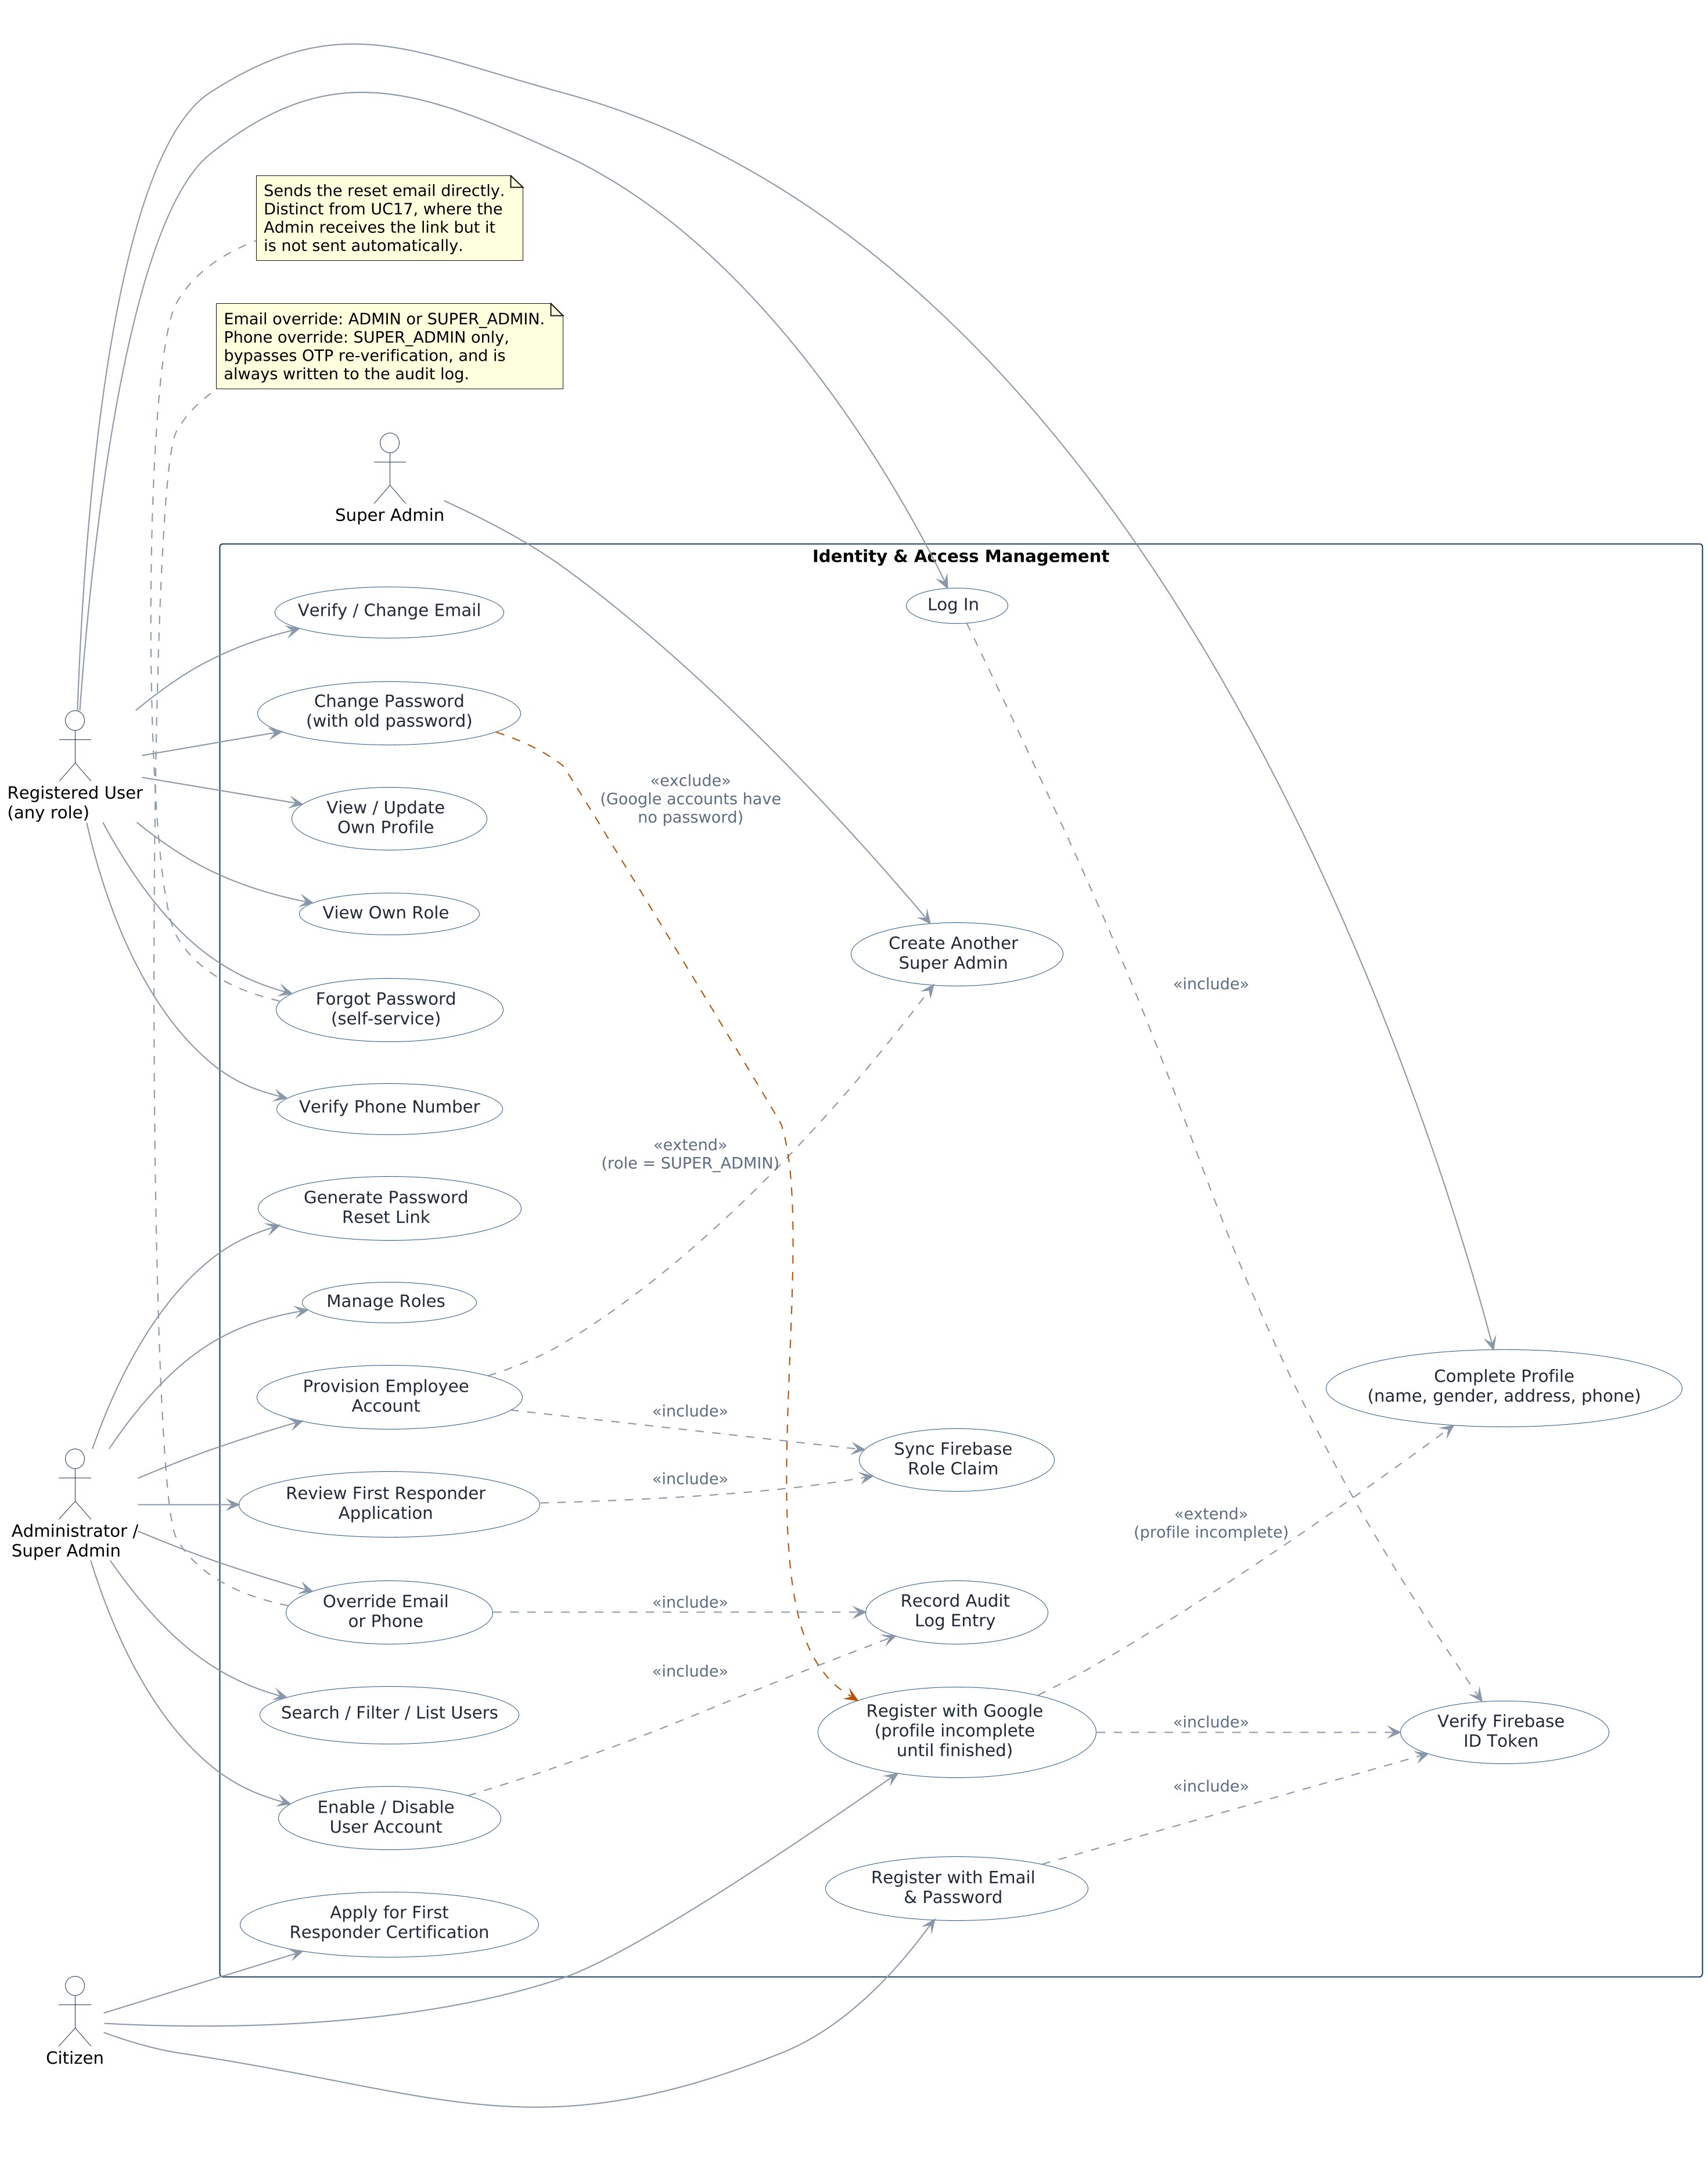
Figure 6.1 — Use case diagram for Identity & Access Management. Dashed relationships are include/extend/exclude system behavior, not directly actor-invoked use cases.

UC-1 — Citizen Registration via Google
Field | Detail
Actor | Citizen
Preconditions | The citizen has signed in with Google through Firebase Auth and holds a valid Firebase ID token. No NAJDA user row exists yet for that Firebase UID.
Postconditions (success) | A new User row is created with role CITIZEN; profileCompleted is false since address, gender, and phone are not yet known; the citizen is prompted to complete their profile before using the rest of the app.
Main flow:
- 1. The citizen signs in with Google via the mobile app.
- 2. The app calls POST /api/auth/register/citizen?provider=google with the resulting Firebase ID token.
- 3. The backend verifies the token and creates the User row using the name and email Google provided.
- 4. Since address, gender, and phone are absent, profileCompleted is computed as false.
- 5. The app shows a profile-completion form requesting first name, last name, gender, address, and phone.
- 6. Submitting the form updates the profile fields and sets the phone number as unverified.
- 7. profileCompleted is recomputed as true once all required fields are present.

UC-2 — Citizen Registration via Email and Password
Field | Detail
Actor | Citizen
Preconditions | The citizen has created a Firebase email/password account and holds a valid Firebase ID token. No NAJDA user row exists yet for that Firebase UID.
Postconditions (success) | A new User row is created with role CITIZEN and profileCompleted true, since every required field was supplied on the form; Firebase has sent an email verification link.
Main flow:
- 1. The citizen fills out the registration form: first name, last name, email, phone, address, gender, password.
- 2. The app creates the Firebase account with that email and password, then triggers Firebase's email verification send.
- 3. The app calls POST /api/auth/register/citizen?provider=password with the Firebase ID token and the full profile.
- 4. The backend creates the User row; because address, gender, and phone are all present, profileCompleted is true immediately.
- 5. The phone number is stored but unverified, the same as the Google path.
Alternate flow — already registered:
- If a user already exists for the UID, the backend returns 409 Conflict and no changes are made.

UC-3 — Admin-Provisioned Employee Registration
Field | Detail
Actor | Administrator or Super Admin
Preconditions | The caller is authenticated with ADMIN or SUPER_ADMIN role. The target role name exists in the roles table.
Postconditions (success) | A Firebase account and a matching NAJDA User row exist for the new employee, in the requested role; a password-reset link has been generated and returned to the Administrator (not emailed automatically).
Postconditions (failure) | No orphaned Firebase account is left behind — if the Postgres write fails after Firebase account creation, the Firebase account is deleted as part of the same request.
Main flow:
- 1. An Admin submits the new employee's details and target role via the web dashboard.
- 2. The backend confirms the caller holds ADMIN or SUPER_ADMIN.
- 3. The backend looks up the requested role by name.
- 4. The backend creates a Firebase account for the employee with a random, never-communicated temporary password.
- 5. The backend creates the matching User row with the requested role.
- 6. The backend sets the Firebase custom claim to match the assigned role.
- 7. The backend generates a password-reset link and returns it to the Admin, who relays it to the new employee themselves.
Alternate flow — requested role is SUPER_ADMIN:
- At step 2, if the requested role is SUPER_ADMIN and the caller is not themselves a SUPER_ADMIN, the request is rejected with Access Denied before any account is created.
Exception flow — Postgres write fails after Firebase account creation:
- The backend deletes the just-created Firebase account to avoid leaving a credential with no corresponding NAJDA user, then surfaces the error.

UC-4 — Enable / Disable a User Account
Field | Detail
Actor | Administrator or Super Admin
Preconditions | The caller holds ADMIN or SUPER_ADMIN. The target user exists.
Postconditions (success) | The target user's enabled flag is flipped. A disabled user fails authentication on their very next request, regardless of an otherwise-valid token.
Postconditions (blocked) | If the target is the last remaining enabled Super Admin, the disable request is rejected and no change is made.
Main flow (disable):
- 1. An Admin selects a user and requests account suspension.
- 2. If the target is a Super Admin, the backend confirms at least one other enabled Super Admin exists.
- 3. The backend sets enabled = false and stamps deletedAt.
- 4. On the user's next request, Spring Security's UserDetails contract reports isEnabled() = false and authentication is refused, even though their Firebase token is still cryptographically valid.
Main flow (re-enable) mirrors the above with enabled = true, clearing deletedAt and restoring authentication immediately.

UC-5 — Administrator Override of Email or Phone
Field | Detail
Actor | Administrator (email) / Super Admin (phone)
Preconditions | The caller holds the required role. The target user exists.
Postconditions (success) | The target's email or phone is updated in both Firebase and Postgres; the new value is unverified until the target user reconfirms it. A phone override additionally writes an audit log entry with the previous and new value.
Main flow (email, ADMIN or SUPER_ADMIN):
- 1. The Admin submits a new email for the target user.
- 2. The backend updates the email on the Firebase account, which resets Firebase's own emailVerified flag to false.
- 3. The backend mirrors the new email into the Postgres profile.
Main flow (phone, SUPER_ADMIN only):
- 1. The Super Admin submits a new phone number for the target user.
- 2. The backend updates the phone number directly on the Firebase account — bypassing the OTP re-verification a self-service change would require.
- 3. The backend mirrors the new phone number into Postgres and marks it unverified.
- 4. Because this bypasses normal verification, the backend always writes an audit log entry recording the previous and new phone number and which Super Admin made the change.

UC-6 — Password Reset (Self-Service and Administrator-Generated)
Field | Detail
Actor | Any user (self-service); Administrator or Super Admin (generated)
Preconditions | The target account authenticates with a password (not Google-only, not phone-only).
Postconditions (self-service) | Firebase sends a password-reset email directly to the user; no administrator is involved.
Postconditions (administrator-generated) | The backend returns a reset link in its response; it is not emailed automatically — the Administrator must relay it to the user themselves.
Main flow (self-service, at login):
- 1. The user selects “Forgot Password” and enters their email.
- 2. Firebase sends the reset email directly to that address.
Main flow (administrator-generated, for an existing account):
- 1. An Admin requests a password reset for a specific user.
- 2. The backend confirms the account actually has a password sign-in provider; Google-only or phone-only accounts are rejected as not applicable.
- 3. The backend generates the reset link via Firebase and returns it in the response, without sending it.
Related, not modeled as a backend endpoint: a user who did not sign up with Google can change their password on the account page by providing their current password; this is handled directly between the client and Firebase.

UC-7 — First Responder Certification Application (Planned)
Field | Detail
Actor | Citizen, Administrator
Preconditions | The applicant holds an active CITIZEN account.
Postconditions (approved) | The applicant's role is updated from CITIZEN to FIRST_RESPONDER; the Firebase custom claim is re-synced.
Postconditions (rejected) | The applicant's role remains CITIZEN; the applicant is notified of the outcome.
Main flow:
- 1. A Citizen submits a First Responder certification application from the mobile app.
- 2. An Administrator reviews the application.
- 3a. If approved, the Administrator's decision updates the applicant's role to FIRST_RESPONDER (equivalent effect to UC-5's role-change path).
- 3b. If rejected, the applicant's role is unchanged.
Not yet decided: what supporting evidence or proof of certification the application requires, whether a review has a target turnaround time, and whether a rejected applicant can reapply.

6.2 Emergency Response Operations
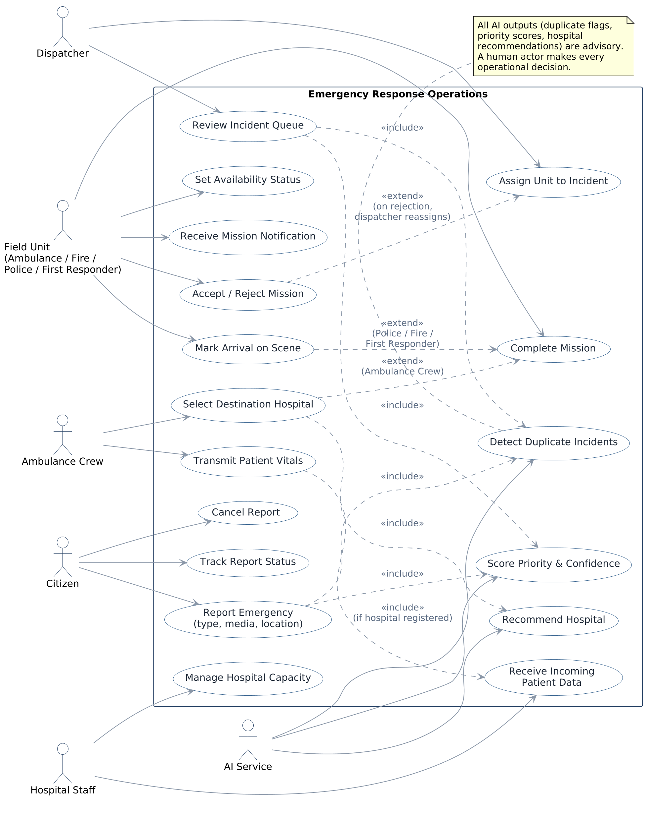
Figure 6.2 — Use case diagram for Emergency Response Operations. Field Unit generalizes Ambulance Crew, Firefighter, Police, and First Responder; Ambulance Crew is shown separately for the hospital-handoff use cases specific to that role. The AI Service is a supporting system actor, never a decision-maker.

UC-8 — Report an Emergency (Planned)
Field | Detail
Actor | Citizen
Preconditions | The Citizen is authenticated.
Postconditions (success) | A new incident exists with a type, description and/or media, and a location, visible to the dispatch queue and checked by the AI service for priority and duplicates.
Main flow:
- 1. The Citizen opens the report screen and selects an incident type: Medical, Police, or Fire.
- 2. The Citizen optionally attaches a photo, video, audio clip, or text message, and shares their current location.
- 3. The Citizen submits the report.
- 4. The backend creates the incident and requests a priority score, confidence value, and duplicate check from the AI service.
- 5. The incident appears in the dispatcher's queue with the AI's output attached.
Alternate flow — cancellation:
- At any point before the operational constraints in Section 8 no longer allow it, the Citizen may cancel the report and must provide a reason.

UC-9 — Assign a Unit to an Incident (Planned)
Field | Detail
Actor | Dispatcher
Preconditions | The incident exists and is not already fully assigned or cancelled.
Postconditions (success) | One or more missions are created, each linked to the incident and to an assigned field-role user or crew; each assignee receives a mission notification.
Main flow:
- 1. The Dispatcher opens an incident from the queue, including its AI-assigned priority, confidence, and any duplicate flag.
- 2. The Dispatcher filters candidate units to those currently available and nearest to the incident.
- 3. The Dispatcher selects an individual account or a grouped crew appropriate to the incident type (Police, Fire, Ambulance, or First Responder).
- 4. The backend creates a mission and notifies the assignee.

UC-10 — Accept or Reject a Mission (Planned)
Field | Detail
Actor | Field-role employee (Ambulance Crew, Firefighter, Police, First Responder)
Preconditions | A mission has been created and the employee has received the notification.
Postconditions (accepted) | The mission moves to En Route; the citizen sees an updated status.
Postconditions (rejected) | The mission returns to the Dispatcher for reassignment, carrying the employee's rejection reason.
Main flow (accept):
- 1. The employee receives the mission notification with incident details and location.
- 2. The employee accepts the mission.
- 3. The employee later marks arrival on scene.
- 4a. For Police, Firefighter, and First Responder missions, arrival marks the mission complete.
- 4b. For Ambulance Crew missions, arrival proceeds to UC-11 (destination hospital selection).
Alternate flow (reject):
- At step 2, the employee rejects the mission and provides a reason; the mission returns to the Dispatcher's assignment view (UC-9).

UC-11 — Ambulance Hospital Handoff (Planned)
Field | Detail
Actor | Ambulance Crew, Hospital Staff
Preconditions | An Ambulance Crew has marked arrival on scene for a mission with a patient requiring transport.
Postconditions (registered hospital) | The mission's destination hospital is set; vital signs sent en route are visible on that hospital's dashboard; the mission completes when the ambulance arrives at the hospital.
Postconditions (unregistered hospital) | The mission's destination hospital is set; no vital-sign transmission occurs; the mission completes once the ambulance arrives and the hospital is selected.
Main flow:
- 1. The Ambulance Crew is shown a list of nearby hospitals with one recommended by the AI service.
- 2. The crew selects a destination hospital, whether or not it is registered in NAJDA.
- 3. If the hospital is registered, the crew may transmit patient vital signs (e.g., heart rate, blood pressure) while en route; Hospital Staff see them arrive on their dashboard as they're sent.
- 4. On arrival at the hospital, the mission is marked complete.
Not yet decided: how a hospital that isn't yet registered gets added to the system's hospital directory, and whether there is a minimum data set Hospital Staff must confirm on receiving a patient.

7. System Architecture and Design

7.1 Architecture Overview
The diagram below contrasts the deployed architecture against the target event-driven microservice architecture. The deployed backend is a single Spring Boot application; the target architecture splits it into independently deployable services communicating over an event broker.
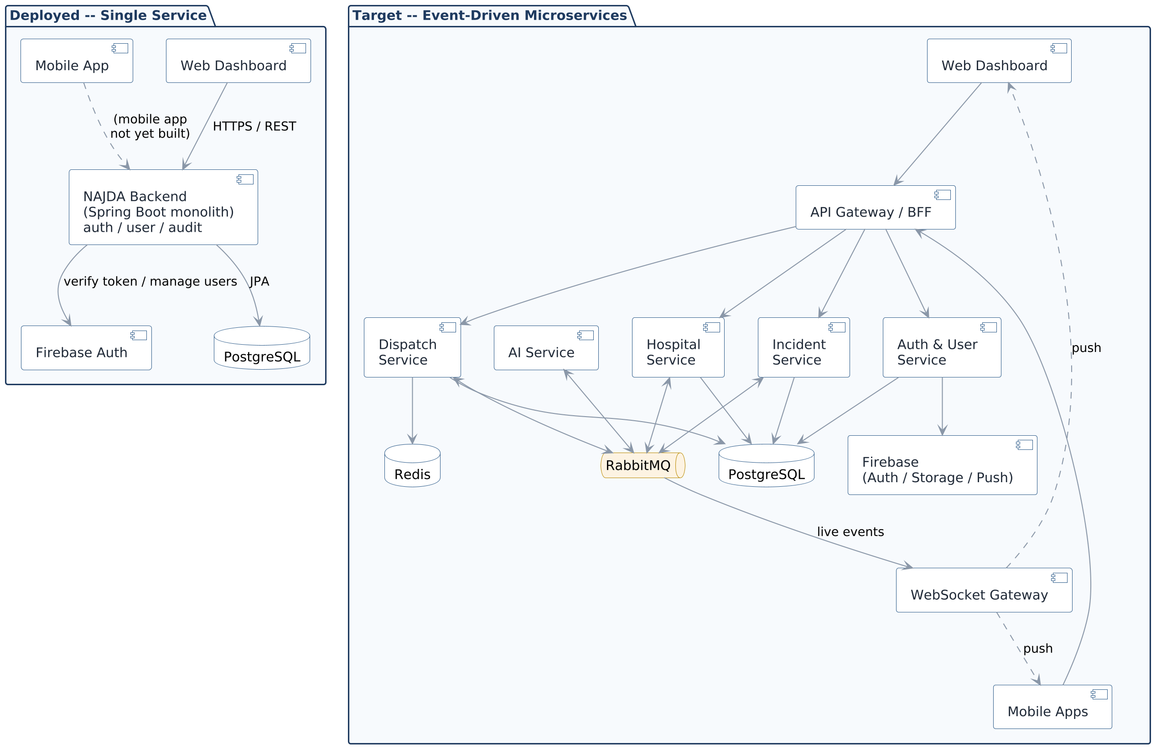
Figure 7.1 — Deployed single-service architecture (top) versus the target microservice architecture (bottom).

7.2 Data Model

7.2.1 Deployed Schema
Three tables exist in the deployed schema: roles, users, and audit_logs. Roles are seeded on startup for all nine actors; a user belongs to exactly one role. The users table tracks phone_verified explicitly; email verification state lives only in Firebase and is never duplicated in Postgres. Suspending a user does not delete their row — it flips enabled to false and stamps deleted_at, preserving history.
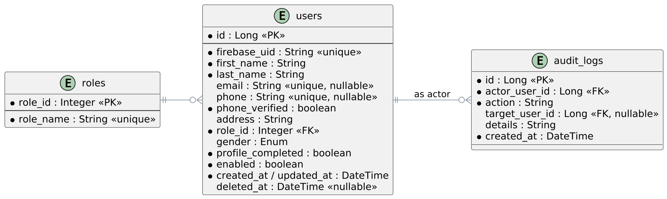
Figure 7.2 — Entity-relationship diagram for the deployed schema.

7.2.2 Target Data Model
The planned schema below supports the full incident-to-completion lifecycle: an incident links to one or more missions, each mission optionally links to a destination hospital and to a stream of vital-sign readings sent by an ambulance crew. Exact column types, indexing, and whether vehicles are tracked per-unit or per-crew are not finalized.
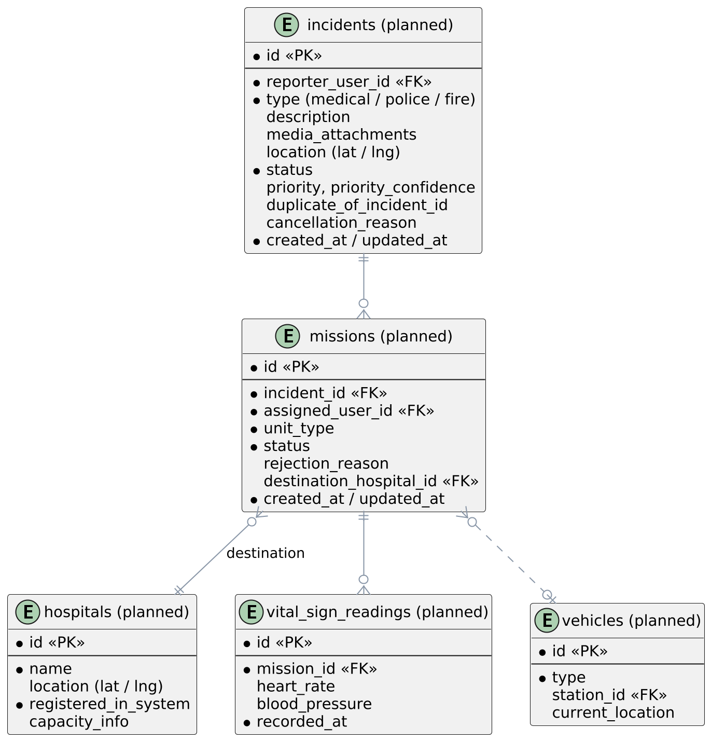
Figure 7.3 — Target data model for incident, mission, hospital, and vital-sign tracking (planned, not yet implemented).

7.3 Class Design
The domain model is intentionally thin at this layer: User (which directly implements Spring Security's UserDetails, rather than wrapping a separate principal type) and Role, with AuditLog as an independent record keyed by user IDs rather than a JPA relationship — it is written by services, not joined against in normal queries. No password is ever stored on User; Firebase Authentication is the sole credential store for password, Google, and phone-OTP sign-in alike. Class design for the Incident, Mission, and Hospital domains will be documented once those modules enter implementation.
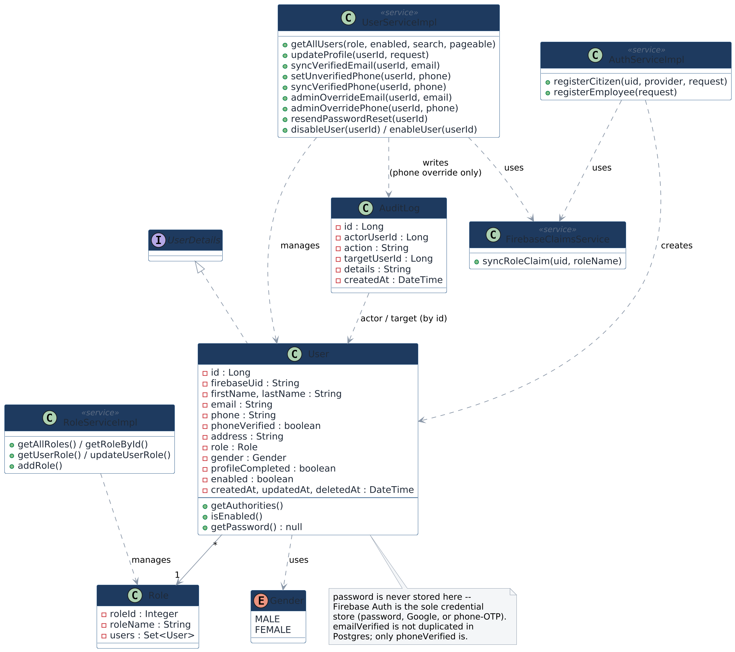
Figure 7.4 — Class diagram for the backend domain and service layer.

7.4 State Model — Incident and Mission Lifecycle
This is the central behavioral model of the operational system: how an incident moves from a citizen's report to a completed response. It applies uniformly across incident types, with one branch specific to Ambulance Crew missions (destination hospital selection) and a rejection path that returns a mission to the dispatcher rather than ending it.
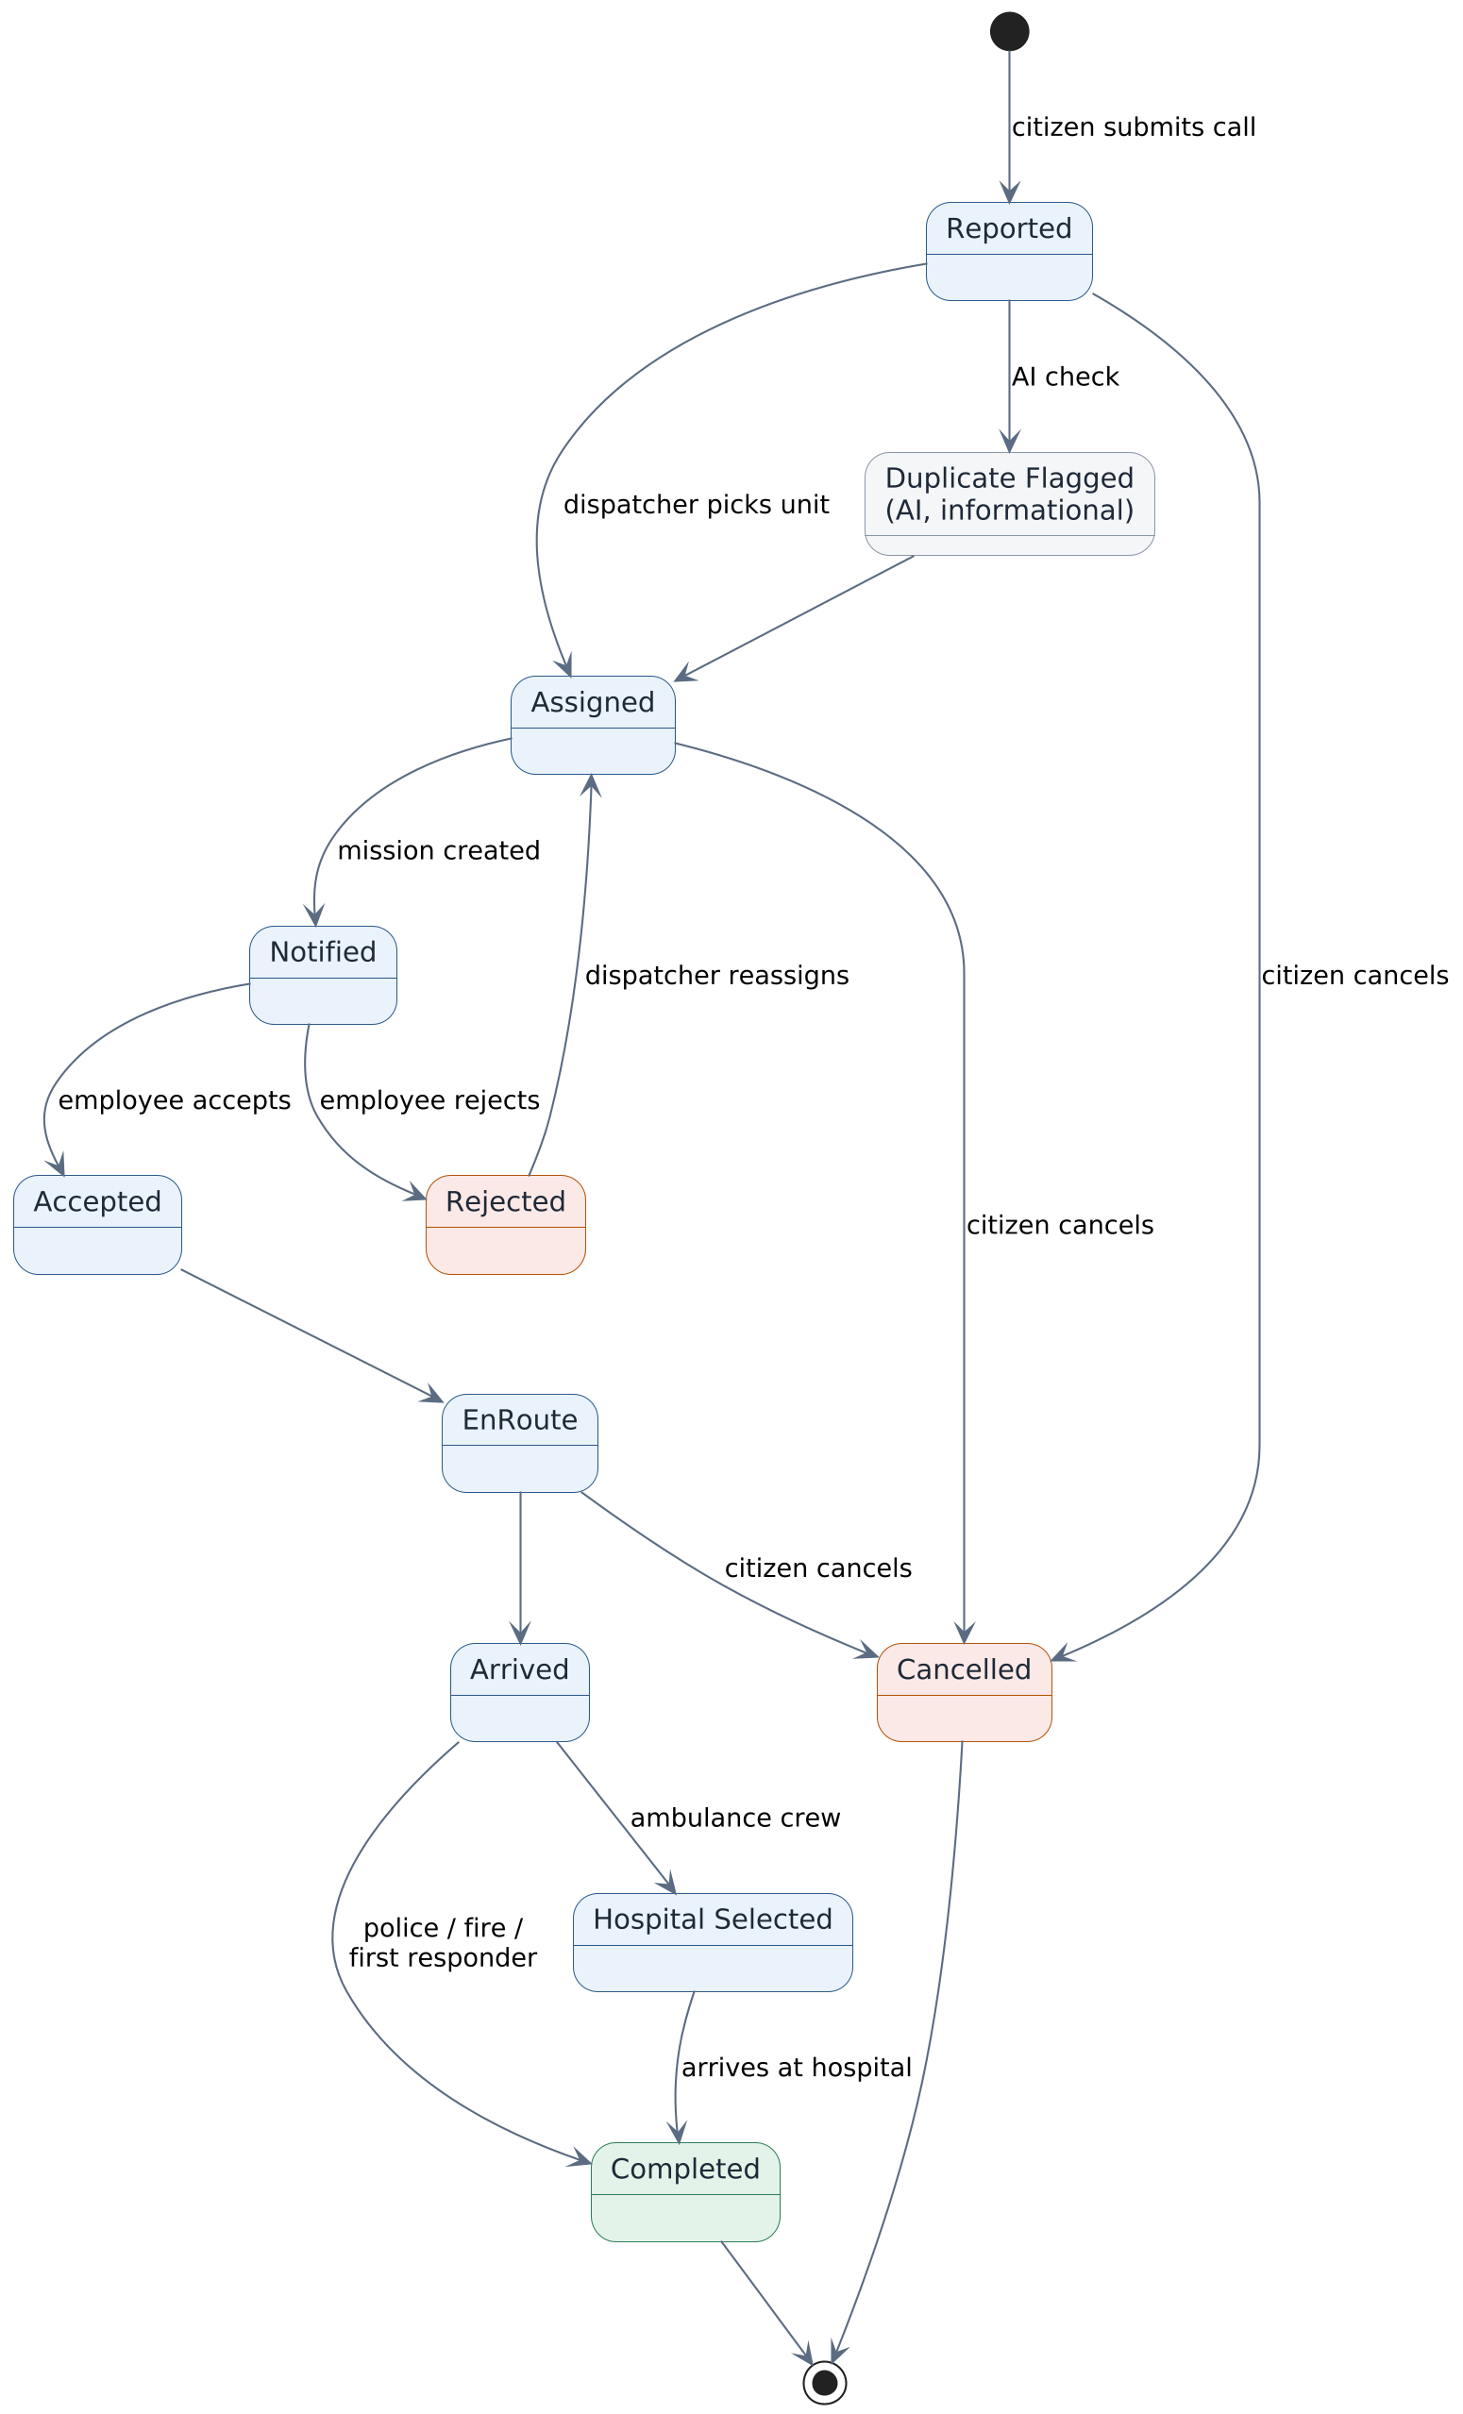
Figure 7.5 — Incident and mission lifecycle (planned). The AI duplicate check is informational only and never blocks assignment on its own.

7.5 Behavioral Views — Sequence Diagrams
The six flows below are the most involved pieces of interaction in the system. The first five are documented against working code; the last describes the planned end-to-end operational flow.
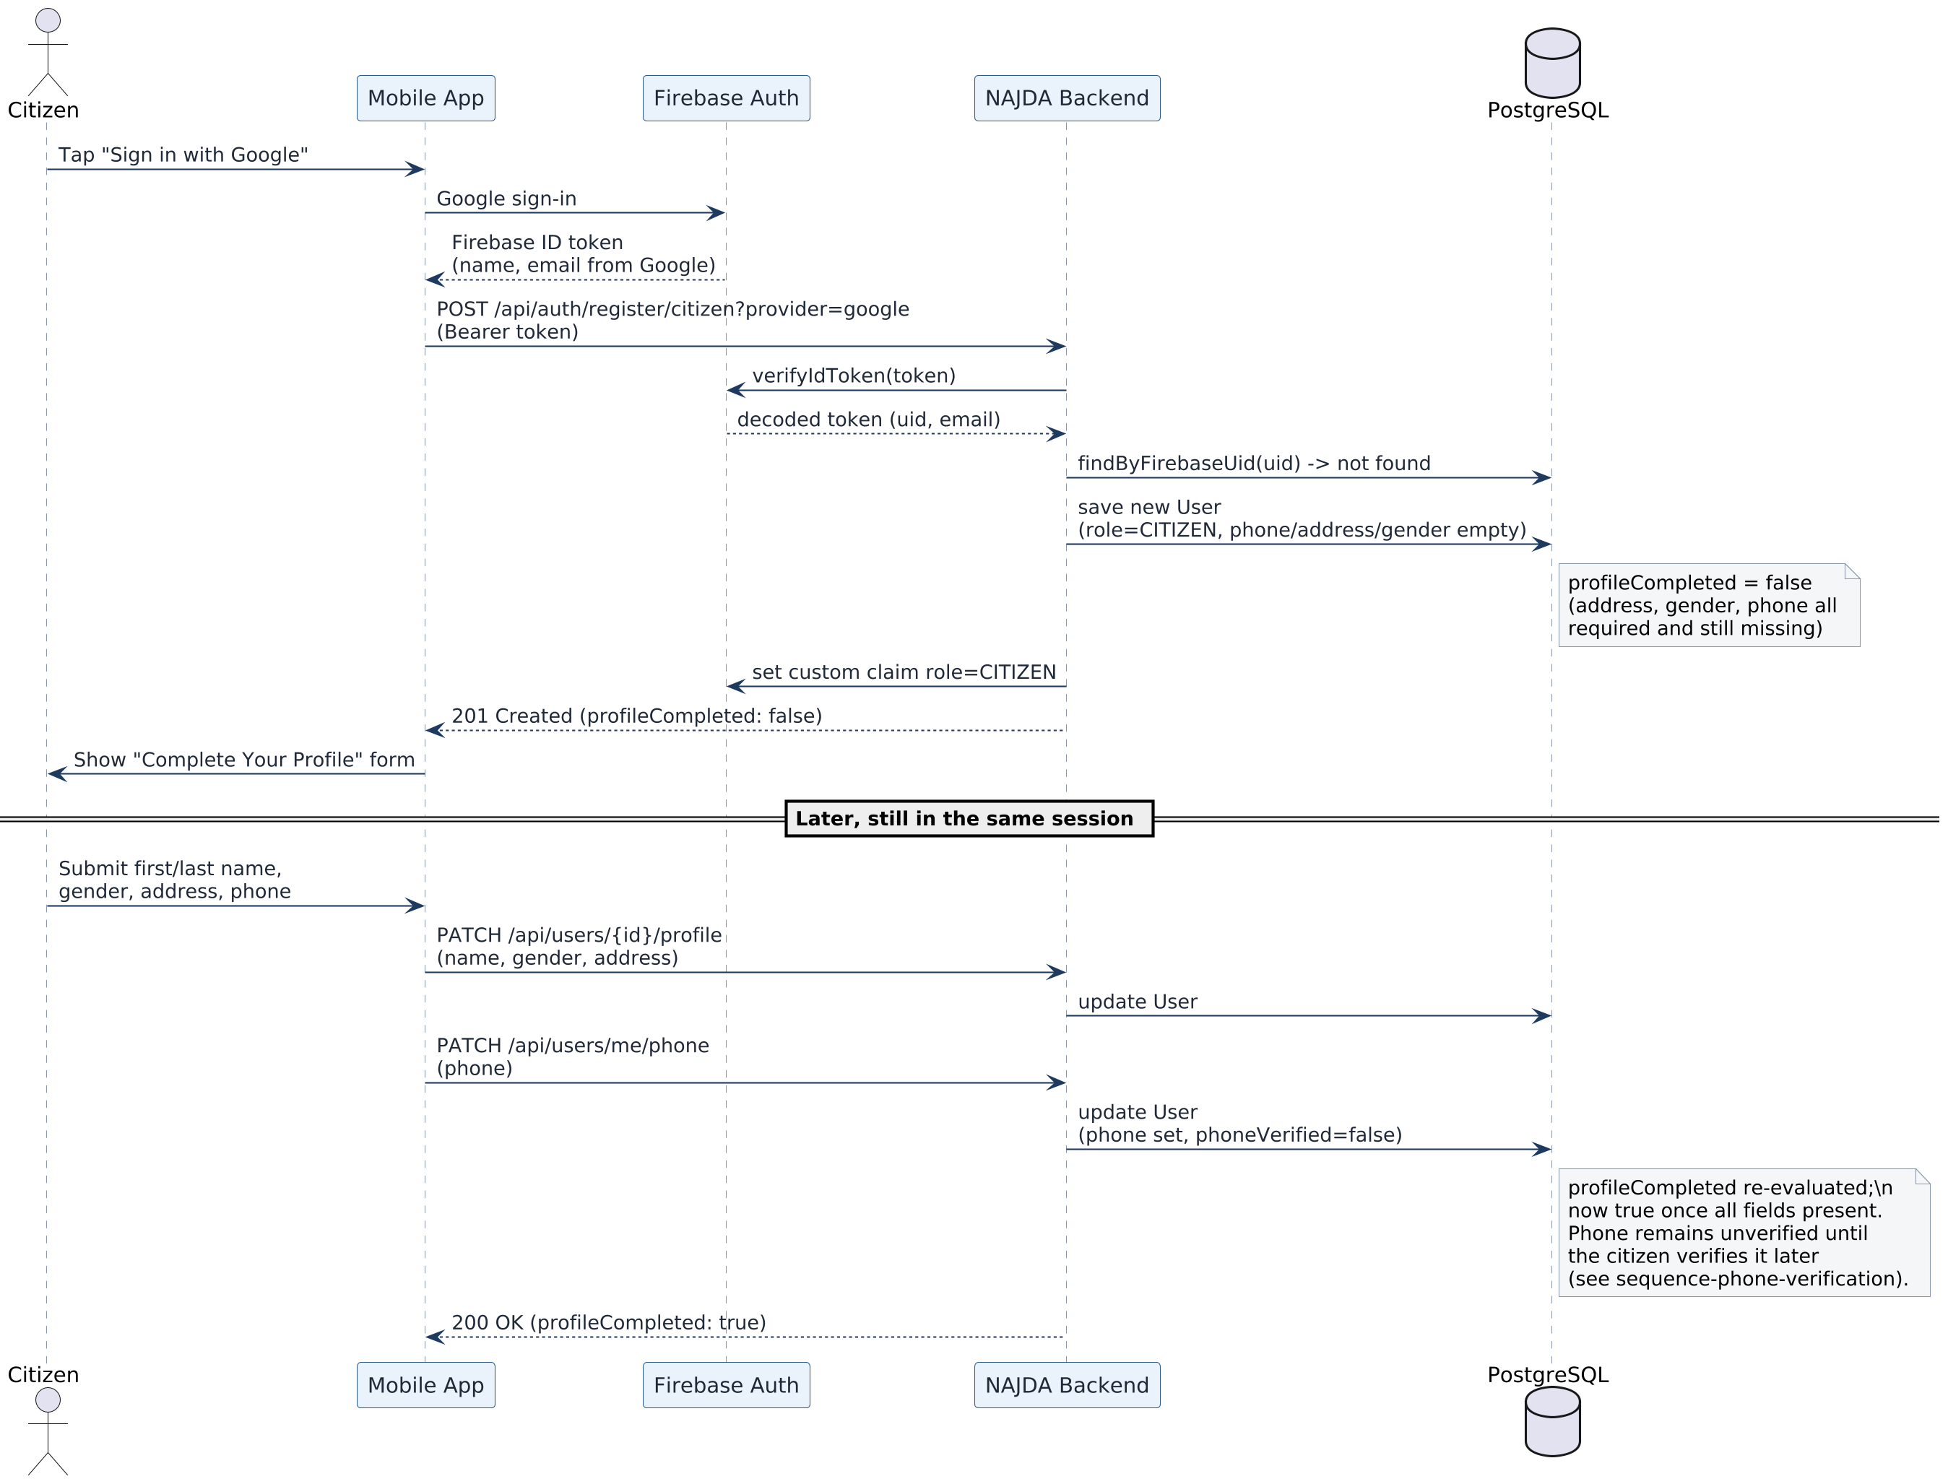
Figure 7.6 — Citizen registration via Google, including the profile-completion step (implemented).
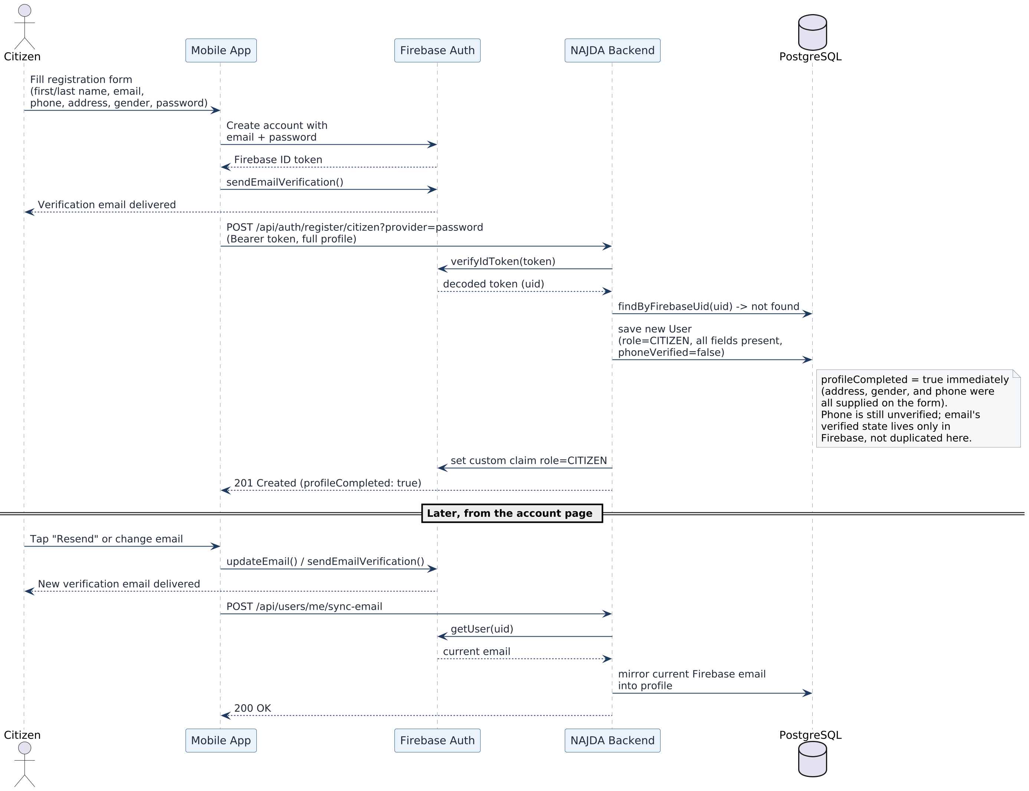
Figure 7.7 — Citizen registration via email and password, including email verification and later re-sync (implemented).
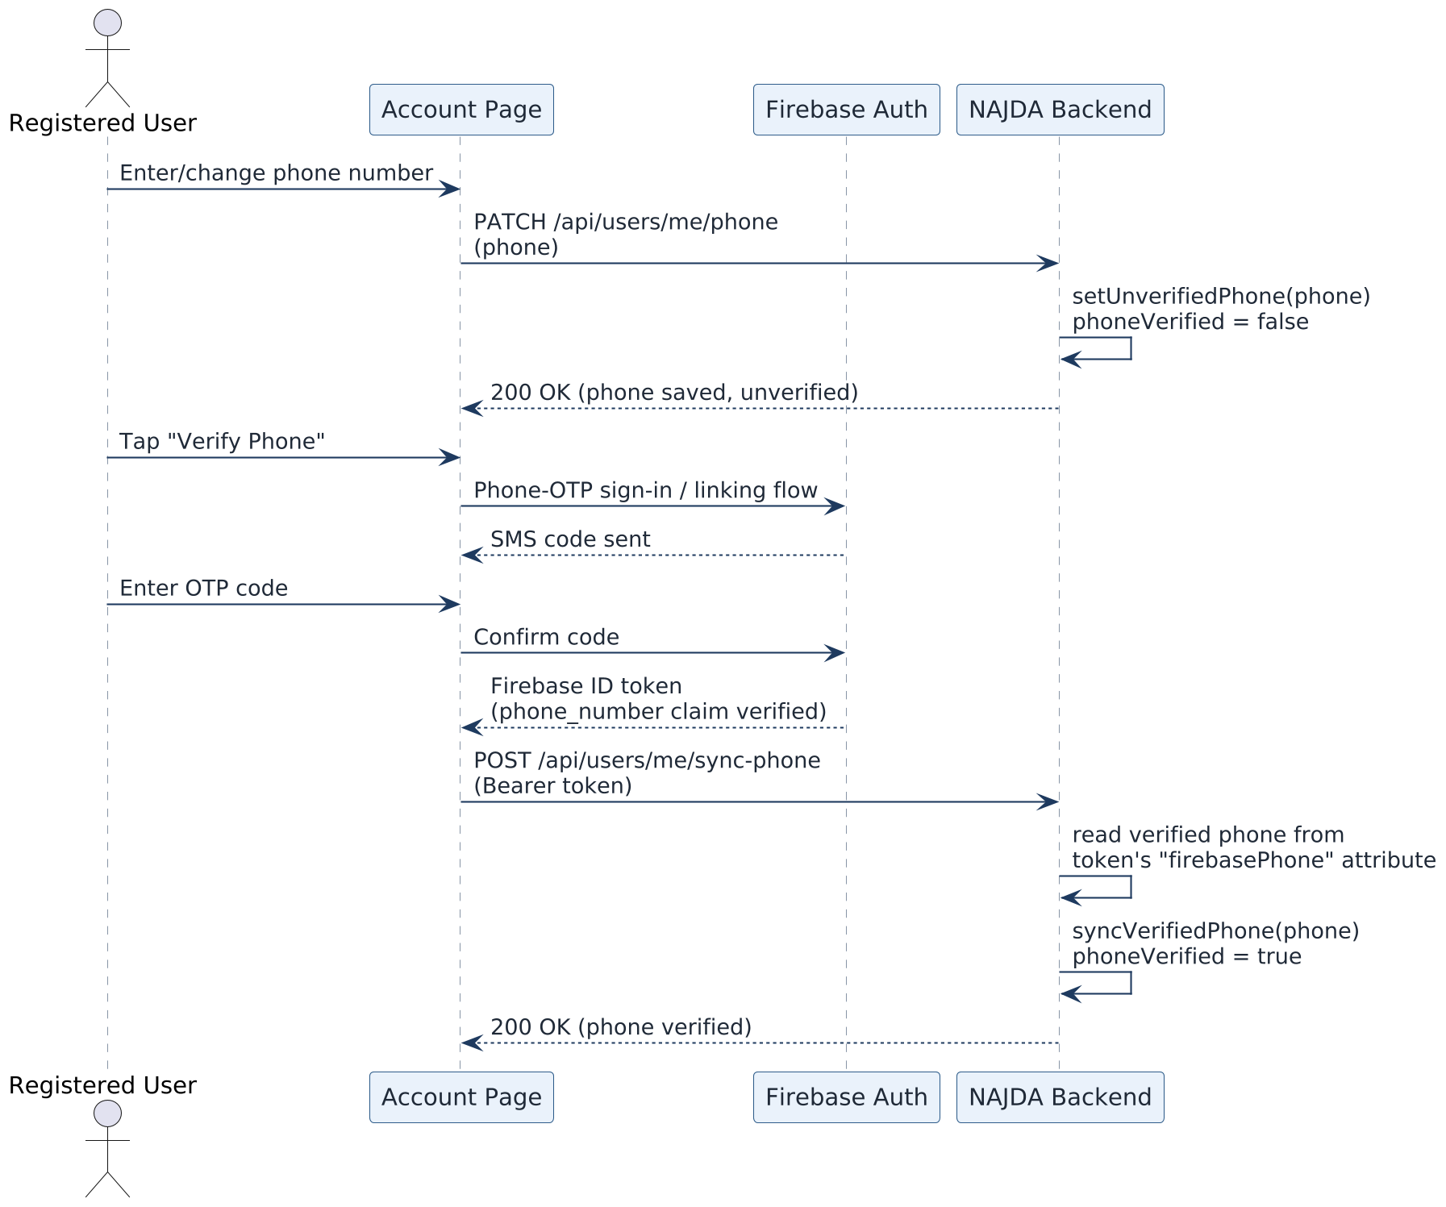
Figure 7.8 — Phone number verification from the account page (implemented).
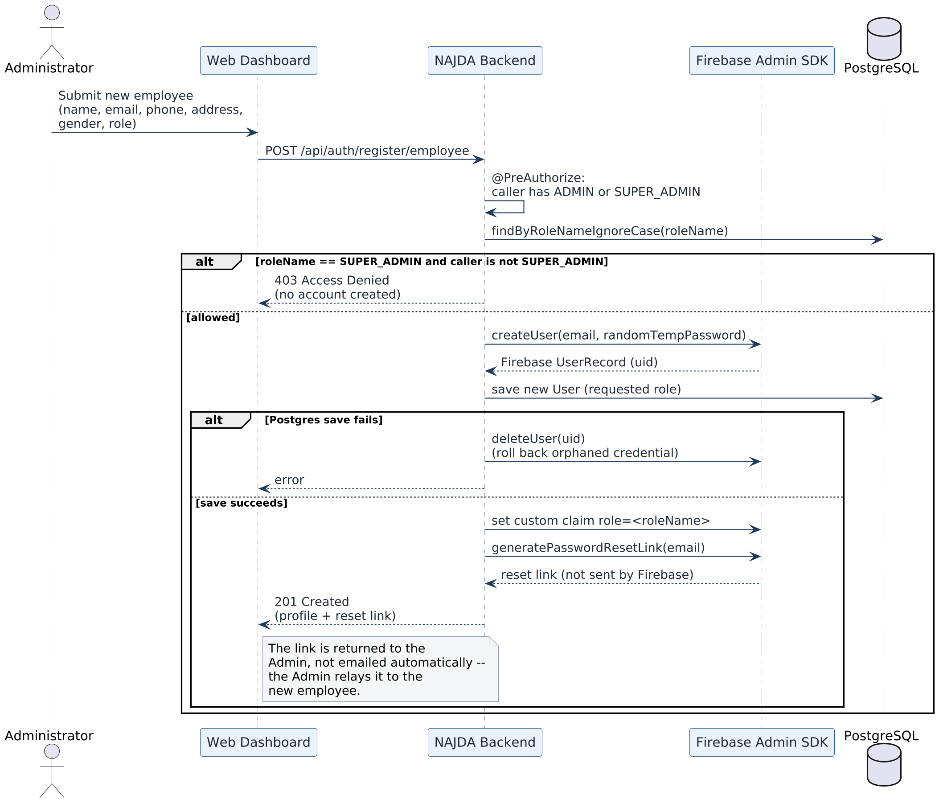
Figure 7.9 — Admin-provisioned employee registration, including the Firebase rollback path on failure (implemented).
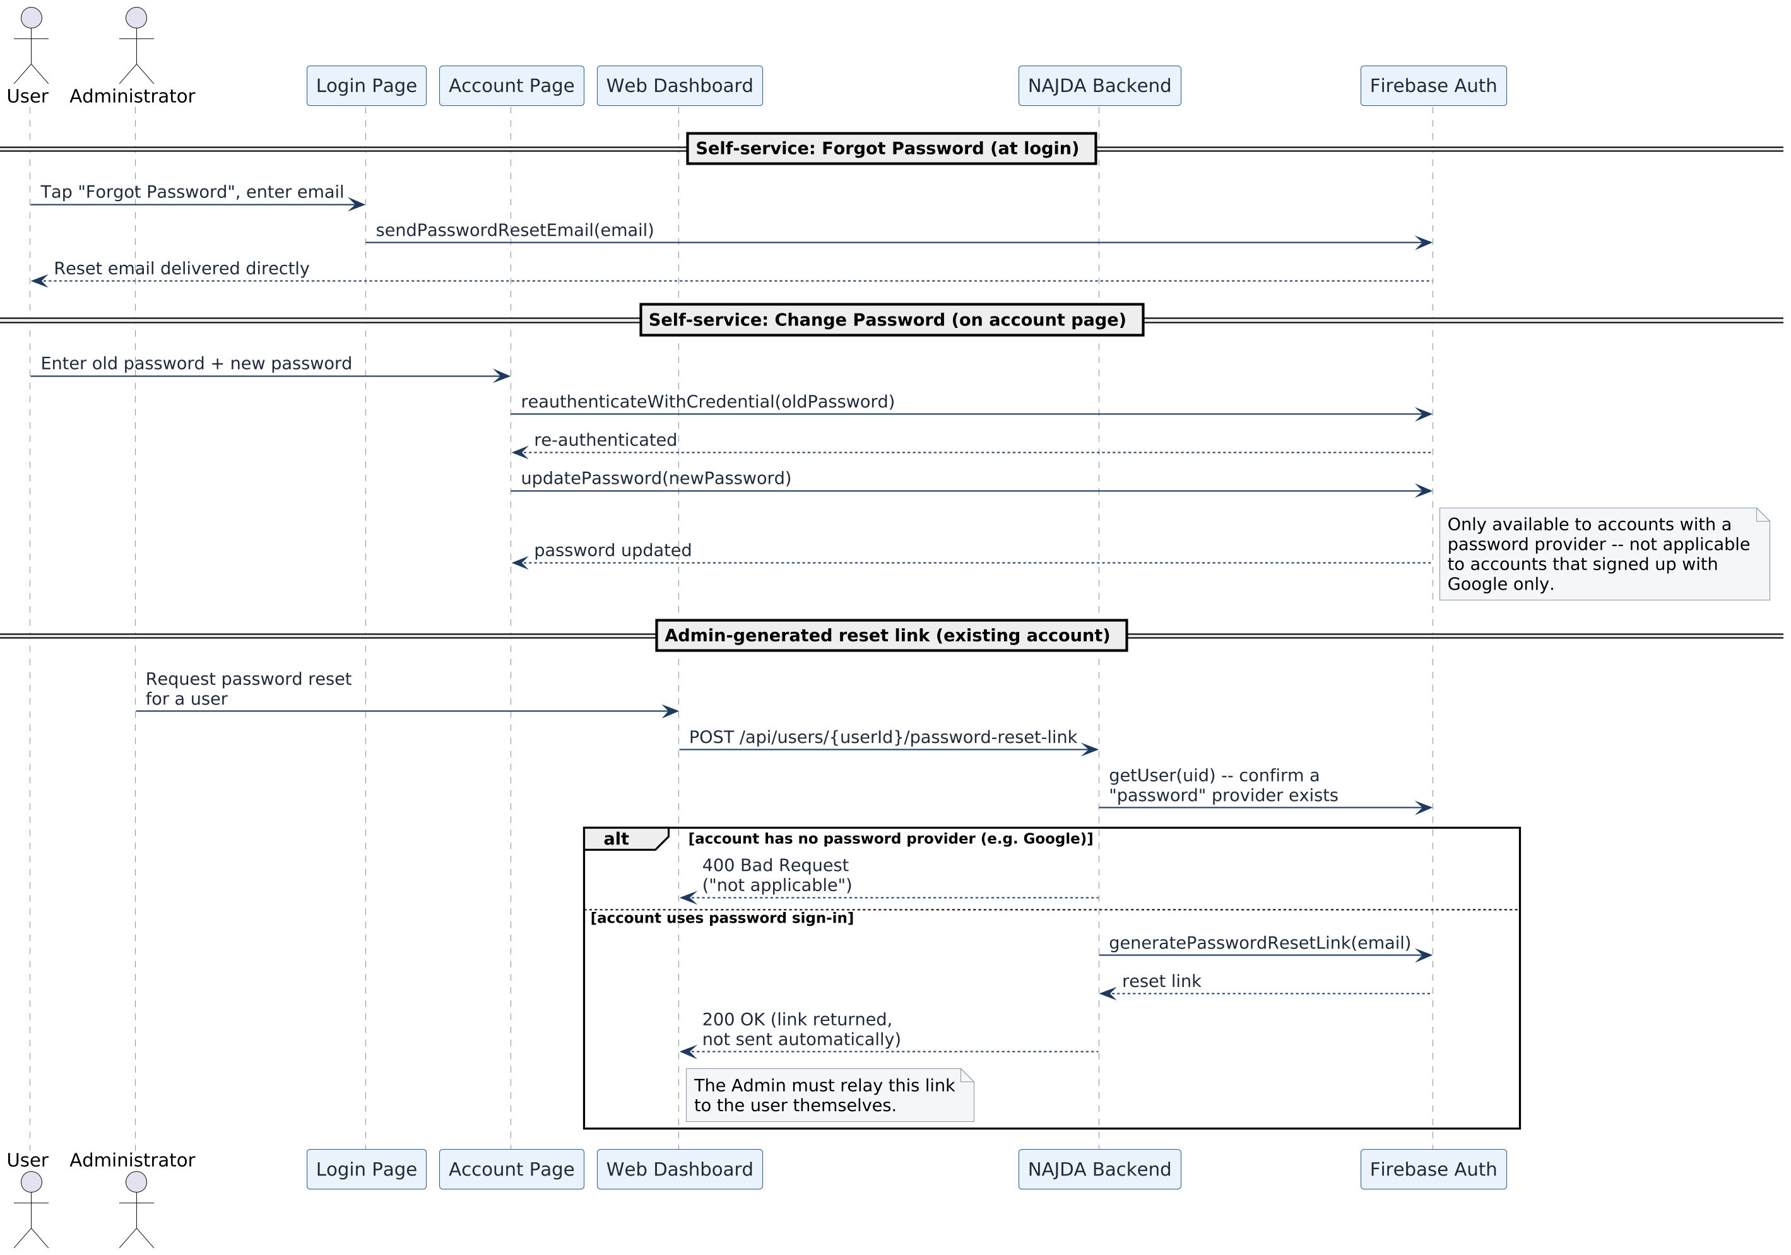
Figure 7.10 — Password reset paths: self-service forgot-password and change-password versus an Administrator-generated reset link (implemented).
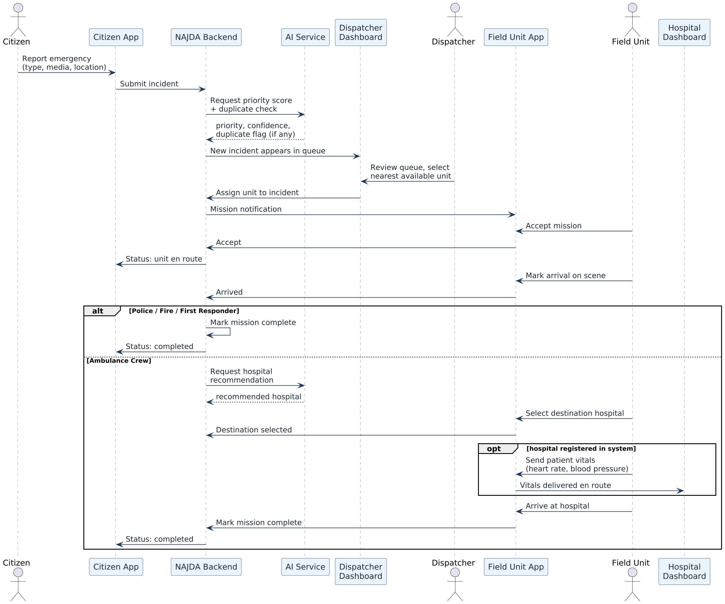
Figure 7.11 — End-to-end emergency response sequence, from citizen report through AI scoring, dispatch, field response, and hospital handoff (planned).

7.6 Authentication and Authorization Model
Authentication and authorization are deliberately decoupled:
- Authentication: every request's Bearer token is verified against Firebase on every call (no server-side session state). A valid token always exposes the caller's UID/email/phone as request attributes, even before any NAJDA account exists for them — this is what allows the citizen registration call itself to be authenticated.
- Authorization: if a valid token resolves to an existing, enabled User row, a full Spring Security Authentication is populated and method-level @PreAuthorize checks (hasRole/hasAnyRole) gate access per endpoint.
- Source of truth: PostgreSQL's role assignment is authoritative. The Firebase custom claim mirrors it for token-level convenience (e.g. client-side route guarding) but is never itself trusted for a backend access-control decision.
- Credential storage: Firebase Authentication holds every credential — password, Google identity, and phone number. NAJDA's own database never stores a password, and only tracks a verified flag for phone, not email.

8. Business Rules

8.1 Identity & Access Management
- A user may access only the functionality permitted by their assigned role.
- Only a Super Admin may create another Super Admin account.
- A plain Admin cannot modify a Super Admin account at all — including disabling it or editing its profile fields — unless they are editing their own account.
- The last remaining enabled Super Admin account cannot be disabled, by anyone.
- A disabled account cannot authenticate, regardless of token validity, from the moment it is disabled.
- Firebase custom claims are always a mirror of the assigned role, never an independent authorization source.
- Every account is tied to exactly one Firebase identity, and, where present, one unique email and one unique phone number.
- A citizen registering with Google has an incomplete profile until first name, last name, gender, address, and phone are all provided; a citizen registering with email and password has a complete profile immediately, since the form collects everything upfront.
- Changing a phone number — by the user themselves or by a Super Admin override — always marks it unverified until re-verified through the OTP flow. A Super Admin's override is the only path that bypasses OTP re-verification, and it is always written to the audit log with the previous and new value.
- Changing an email — by the user or by an Admin override — resets its verified state in Firebase; email verification is never tracked in NAJDA's own database, only in Firebase.
- An Administrator-generated password-reset link is returned to the Administrator, not emailed automatically, and is only offered for accounts that sign in with a password. A user's own “Forgot Password” request is emailed directly by Firebase.
- A citizen's role may be upgraded to First Responder only through administrator approval of a certification application, or by direct administrator provisioning — never automatically.

8.2 Emergency Response Operations
- Every incident has exactly one type: Medical, Police, or Fire, set at the time it is reported.
- Every mission is assigned to exactly one field-role user or crew at a time; a rejected mission returns to the dispatcher rather than remaining assigned to the employee who rejected it.
- For Police, Firefighter, and First Responder missions, arrival at the scene marks the mission complete.
- For Ambulance Crew missions, completion additionally requires a destination hospital to be selected and, when that hospital is registered in the system, for the ambulance to arrive there.
- Patient vital-sign transmission to a hospital dashboard is only available when the destination hospital is registered in the system.
- AI-generated priority scores, duplicate flags, and hospital recommendations are advisory only; the dispatcher or field crew retains the operational decision in every case.
- Every incident and mission maintains a complete history of its operational events.
- A citizen may cancel an active report, providing a reason; the operational constraints on when cancellation is still allowed depend on the mission's current status.

9. Testing Strategy
A formal test plan, coverage targets, and CI gating will be documented as automated testing is built out. At present the backend includes only the default Spring Boot application-context test.
Intended approach:
- Unit tests around service-layer business logic (profile-completion computation, role resolution, account provisioning, claim synchronization, the Super Admin protection rules, mission state transitions once implemented).
- Integration tests against a real PostgreSQL instance for repository and controller behavior.
- Contract or end-to-end tests covering both citizen registration paths (Google and email/password), phone verification, and password-reset flows across mobile/web clients, Firebase, and the backend.
- Scenario-based end-to-end tests covering the full incident lifecycle once Emergency Response Operations is implemented: report, AI scoring, assignment, accept/reject, arrival, and hospital handoff.
- Manual exploratory testing of the web dashboard prior to each release.

10. Requirements Traceability Matrix
Each requirement is linked to the story that motivates it, the use case that details it, and the component that satisfies or will satisfy it, so any row can be checked directly against the repository for implemented items.
Req. | User Story | Use Case | Component
FR-1 | US-1 | UC-1 | AuthController / AuthServiceImpl (provider=google)
FR-2 | US-2 | UC-2 | AuthController / AuthServiceImpl (provider=password)
FR-3 | US-1, US-2 | UC-1, UC-2 | FirebaseTokenAuthFilter
FR-4 | US-1 | UC-1 | User.profileCompleted / recomputeProfileCompleted
FR-5 | US-12 | UC-3 | AuthController.registerEmployee / AuthServiceImpl
FR-6 | US-13 | UC-3 | AuthServiceImpl.registerEmployee (SUPER_ADMIN guard)
FR-7 | US-12 | UC-3 | AuthServiceImpl.registerEmployee (reset link)
FR-8 | US-6 | — | UserController.updateProfile / UserServiceImpl
FR-9 | US-4 | — | UserController.setUnverifiedPhone
FR-10 | US-4 | — | UserController.syncVerifiedPhone
FR-11 | US-5 | — | UserController.syncEmail / UserServiceImpl
FR-12 | US-17 | UC-5 | UserController.adminOverrideEmail
FR-13 | US-17 | UC-5 | UserController.adminOverridePhone
FR-14 | US-14 | — | UserController.getAllUsers
FR-15 | US-19 | UC-6 | UserController.resendPasswordReset
FR-16 | US-9 | UC-6 | Firebase client SDK (reauthenticate + updatePassword)
FR-17 | US-8 | UC-6 | Firebase client SDK (sendPasswordResetEmail)
FR-18 | US-15 | UC-4 | UserController.disableUser
FR-19 | US-15 | UC-4 | UserServiceImpl.disableUser (last Super Admin guard)
FR-20 | US-16 | UC-4 | UserController.enableUser
FR-21 | US-7, US-18 | UC-5 | RolesController
FR-22 | — | — | SecurityConfig, @PreAuthorize across controllers
FR-23 | — | UC-3, UC-5 | FirebaseClaimsService.syncRoleClaim
FR-24 | US-3 | UC-7 | Planned — Identity Service
FR-25 | US-20 | UC-7 | Planned — Identity Service
FR-26 | US-10 | — | Planned — Field Response Service
FR-27 | US-11 | — | Planned — Identity Service
FR-28 | US-21 | UC-8 | Planned — Incident Service
FR-29 | US-22 | UC-8 | Planned — Incident Service
FR-30 | US-23 | UC-8 | Planned — Incident Service
FR-31 | US-24 | UC-8 | Planned — Incident Service
FR-32 | US-25 | — | Planned — Incident Service
FR-33 | US-26 | UC-9 | Planned — Dispatch Service
FR-34 | US-27 | UC-9 | Planned — Dispatch Service, AI Service
FR-35 | US-28 | UC-9 | Planned — Dispatch Service, AI Service
FR-36 | US-29 | UC-9 | Planned — Dispatch Service
FR-37 | US-29 | UC-9 | Planned — Dispatch Service
FR-38 | US-30 | UC-10 | Planned — Field Response Service
FR-39 | US-31 | UC-10 | Planned — Field Response Service
FR-40 | US-31 | UC-10 | Planned — Dispatch Service
FR-41 | US-32 | UC-10 | Planned — Field Response Service
FR-42 | US-33 | UC-10 | Planned — Field Response Service
FR-43 | US-34 | UC-11 | Planned — Hospital Service
FR-44 | US-35 | UC-11 | Planned — Hospital Service
FR-45 | US-36 | UC-11 | Planned — Hospital Service
FR-46 | US-36 | UC-11 | Planned — Hospital Service
FR-47 | US-37 | UC-11 | Planned — Hospital Service
FR-48 | US-38 | — | Planned — Hospital Service
FR-49 | US-39 | — | Planned — AI Service
FR-50 | US-39 | — | Planned — AI Service
FR-51 | US-40 | UC-11 | Planned — AI Service
FR-52 | — | — | Planned — AI Service
FR-53 | — | — | Planned — AI Service (Section 8 governs)

11. Assumptions and Constraints

11.1 Assumptions
- Mobile devices used by citizens and field units have working GPS and location services.
- Devices have reliable internet connectivity during normal operation.
- Participating emergency organizations and hospitals keep their operational information (availability, capacity) up to date.
- The platform operates as an academic simulation rather than a certified emergency-services integration.

11.2 Constraints
- The system does not integrate with official governmental emergency communication or dispatch systems.
- AI recommendations are advisory only and cannot autonomously dispatch, reassign, or cancel a mission.
- Development proceeds iteratively and dependency-ordered (Identity & Access Management first, since every other module depends on it); a fixed sprint length and ceremony cadence have not yet been set.

12. Open Decisions
Items below are deliberately left open rather than guessed at. Each will be resolved and folded into the relevant section above as the design is finalized.
- Exact field-role availability status values (Available / Busy / Offline proposed) and whether additional states are needed.
- Whether citizens can manually pinpoint a location on a map in addition to sharing device GPS location.
- First Responder certification: what proof or evidence an application requires, expected review turnaround, and whether a rejected applicant can reapply.
- Whether field crews are modeled as fixed teams or dynamically grouped per shift, and the exact nearest/available-unit matching algorithm.
- Mission acceptance timeout and whether/how an unanswered mission is automatically reassigned.
- The precise operational constraints governing how late a citizen may still cancel a report.
- Process for adding a hospital that isn't yet registered to the system's hospital directory, and any minimum data set Hospital Staff must confirm on receiving a patient.
- Development iteration length and ceremonies (planning, review, retrospective).

Appendix A — Technology Stack
Layer | Technology
Backend | Java 21, Spring Boot 4, Spring Security, Spring Data JPA, Flyway, Spring AMQP (RabbitMQ), springdoc-openapi
Web | Next.js 16 (App Router), React 19, TypeScript, Tailwind CSS 4, TanStack Query, Zustand
Mobile | Flutter, cross-platform Android/iOS
Database | PostgreSQL (system of record); Redis for live-location caching
Messaging | RabbitMQ
Auth | Firebase Authentication — sole store of passwords, Google identities, and phone numbers; PostgreSQL is the source of truth for authorization
AI | Priority classification, duplicate detection, hospital ranking, hazard image classification

Appendix B — API Reference
Endpoints implemented by the Identity & Access Management module.
Method & Path | Description | Authorization
POST /api/auth/register/citizen?provider={google|password} | Register a citizen; provider determines whether the profile starts complete or incomplete. | Valid Firebase token (no existing account)
POST /api/auth/register/employee | Provision an employee account with an assigned role. | ADMIN or SUPER_ADMIN
GET /api/auth/me | Retrieve the authenticated caller's profile. | Any authenticated user
GET /api/users | List, search, filter, and paginate all users. | ADMIN or SUPER_ADMIN
PATCH /api/users/{userId}/profile | Update first name, last name, gender, and address. | Owner, ADMIN, or SUPER_ADMIN (not for another SUPER_ADMIN's account)
PATCH /api/users/me/phone | Set a new phone number for the caller; marks it unverified. | Any authenticated user
POST /api/users/me/sync-phone | Mark the caller's phone verified after completing the OTP flow. | Any authenticated user
POST /api/users/me/sync-email | Mirror the caller's current Firebase email into their profile. | Any authenticated user
POST /api/users/{userId}/admin-override-email | Directly set a user's email; resets Firebase email verification. | ADMIN or SUPER_ADMIN
POST /api/users/{userId}/admin-override-phone | Directly set a user's phone number, bypassing OTP; always audit-logged. | SUPER_ADMIN
POST /api/users/{userId}/password-reset-link | Generate a reset link for an existing account and return it (not sent automatically). | ADMIN or SUPER_ADMIN
POST /api/users/{userId}/disable | Suspend a user account. | ADMIN or SUPER_ADMIN (blocked for the last enabled SUPER_ADMIN)
POST /api/users/{userId}/enable | Re-enable a suspended user account. | ADMIN or SUPER_ADMIN
GET /api/roles | List all roles. | ADMIN or SUPER_ADMIN
POST /api/roles | Create a new role. | ADMIN or SUPER_ADMIN
GET /api/roles/{roleId} | Retrieve a role by ID. | ADMIN or SUPER_ADMIN
GET /api/users/{userId}/role | Retrieve a user's assigned role. | Owner, ADMIN, or SUPER_ADMIN
PATCH /api/users/{userId}/role | Change a user's assigned role. | ADMIN or SUPER_ADMIN
Forgot Password and Change Password are handled directly between the client and Firebase Authentication (sendPasswordResetEmail, reauthenticateWithCredential, updatePassword) and are not backend endpoints. Endpoints for Emergency Reporting, Dispatch Operations, Field Response, Hospital Coordination, and AI-Assisted Decision Support will be added here as each module is implemented.

Appendix C — Glossary and Abbreviations
Term | Meaning
RBAC | Role-Based Access Control
OTP | One-Time Password
JWT | JSON Web Token
CRUD | Create, Read, Update, Delete
SDLC | Software Development Lifecycle
ER Diagram | Entity-Relationship Diagram
UML | Unified Modeling Language
Provider | The Firebase sign-in method behind an account: Google, password, or phone.
Profile Completed | A flag indicating a citizen has supplied every required profile field (name, gender, address, phone).
Incident | A reported emergency event tracked through NAJDA from report to closure.
Mission | A single field unit's assignment to respond to a specific incident.
Field Unit | Collective term for Ambulance Crew, Firefighter, Police, and First Responder roles.
Availability Status | A field-role employee's current shift state (proposed: Available, Busy, Offline).
Priority Score | An AI-generated estimate of how urgently an incident needs a response.
Confidence Level | How reliable the AI considers its own priority score or duplicate flag to be.
Duplicate Detection | AI comparison of near-simultaneous reports to flag likely repeat reports of the same incident.
Certification Application | A citizen's submitted request to be granted the First Responder role.

